Dependencies defined in **auth_service/go.mod**

* **github.com/dgrijalva/jwt-go**

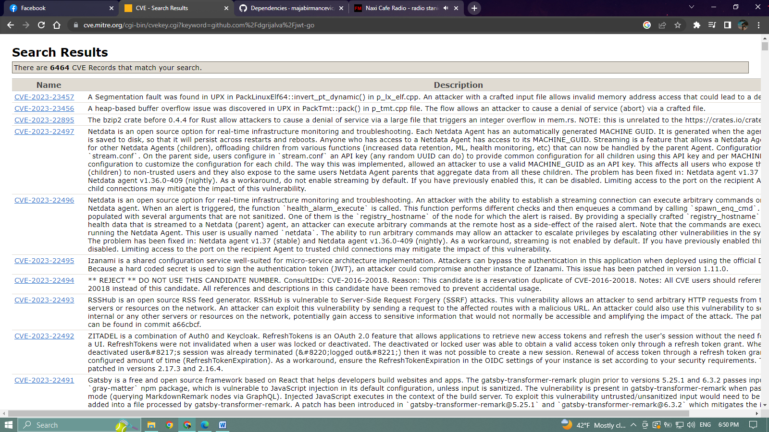**link:** [**https://cve.mitre.org/cgi-bin/cvekey.cgi?keyword=github.com%2Fdgrijalva%2Fjwt-go**](https://cve.mitre.org/cgi-bin/cvekey.cgi?keyword=github.com%2Fdgrijalva%2Fjwt-go)

* **github.com/felixge/httpsnoop**

**link:** [**https://cve.mitre.org/cgi-bin/cvekey.cgi?keyword=github.com%2Ffelixge%2Fhttpsnoop**](https://cve.mitre.org/cgi-bin/cvekey.cgi?keyword=github.com%2Ffelixge%2Fhttpsnoop)

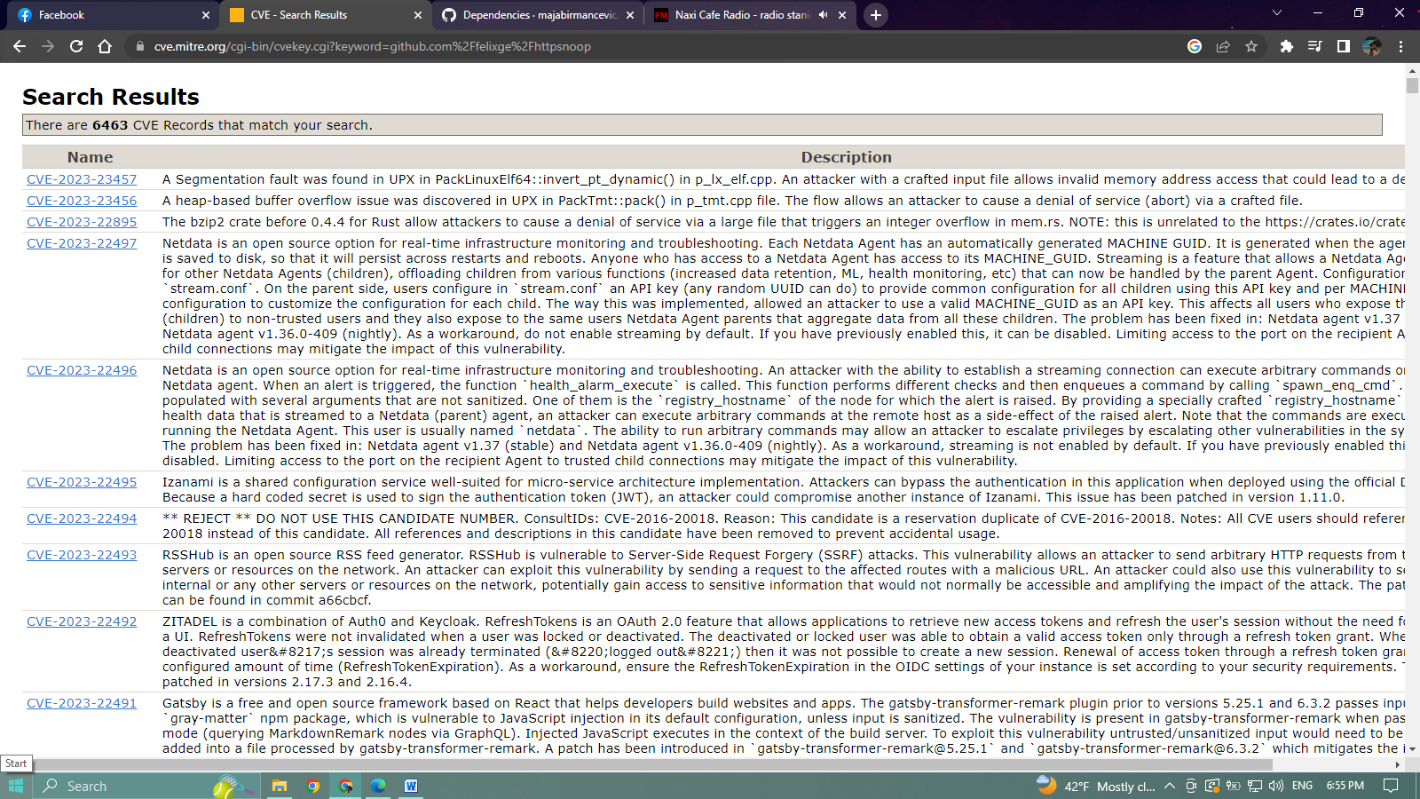

* **github.com/golang/snappy**

**link**: <https://cve.mitre.org/cgi-bin/cvekey.cgi?keyword=github.com%2Fgolang%2Fsnappy>

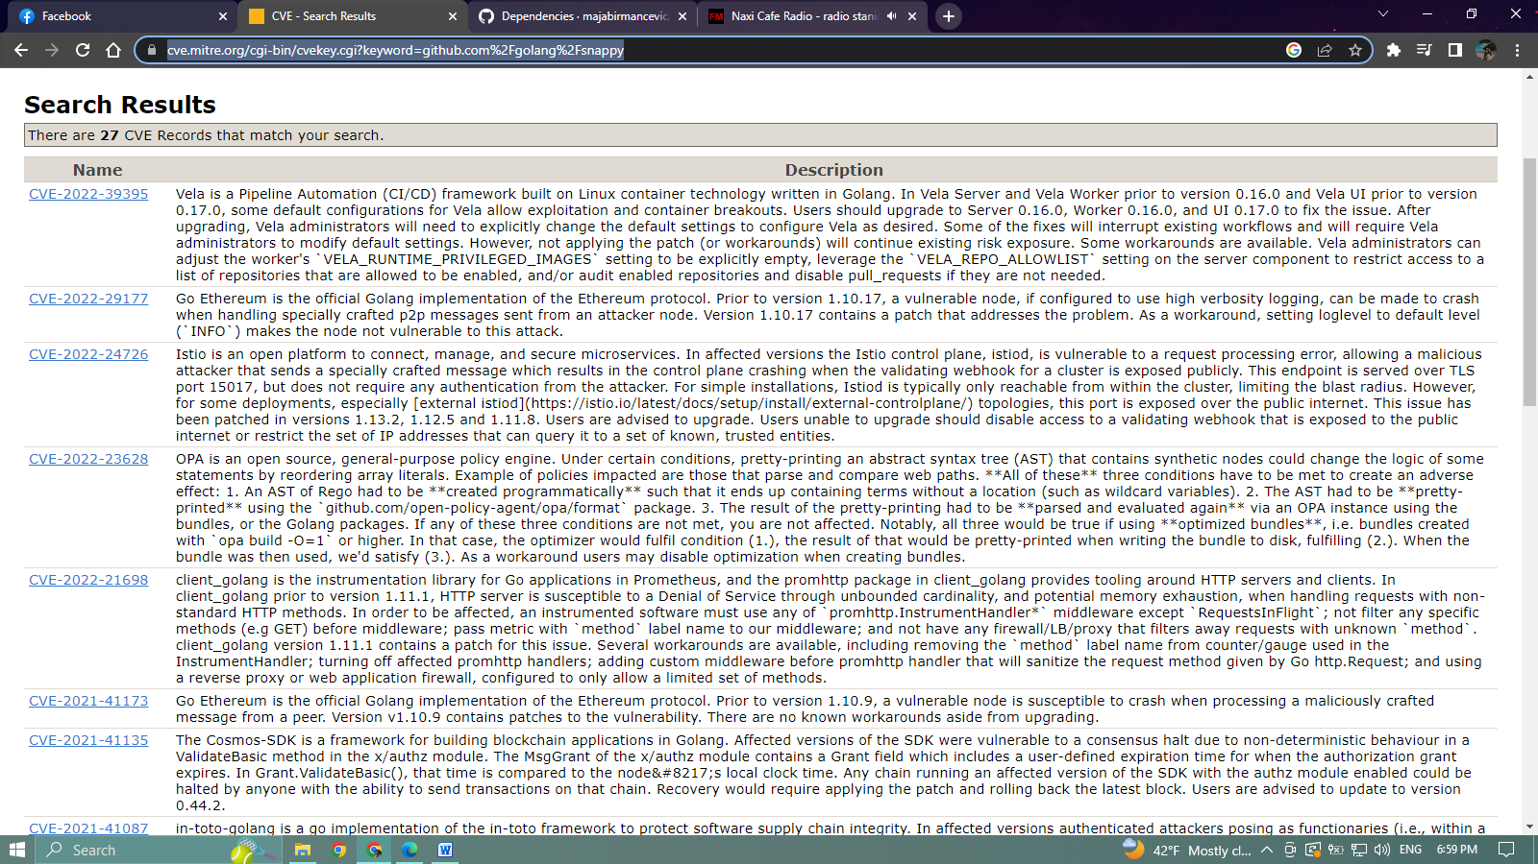

* **github.com/google/go-cmp**

**link:** [**https://cve.mitre.org/cgi-bin/cvekey.cgi?keyword=github.com%2Fgoogle%2Fgo-cmp**](https://cve.mitre.org/cgi-bin/cvekey.cgi?keyword=github.com%2Fgoogle%2Fgo-cmp)

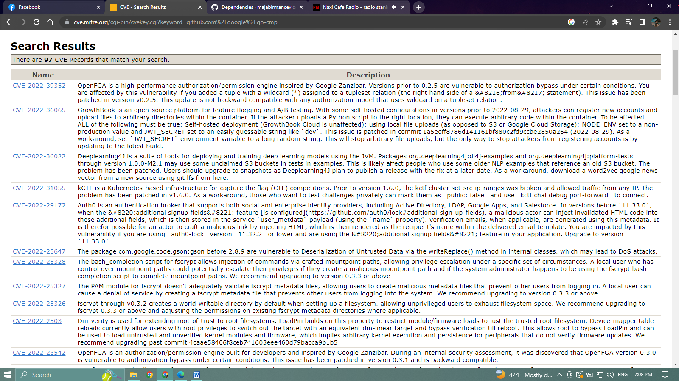

* 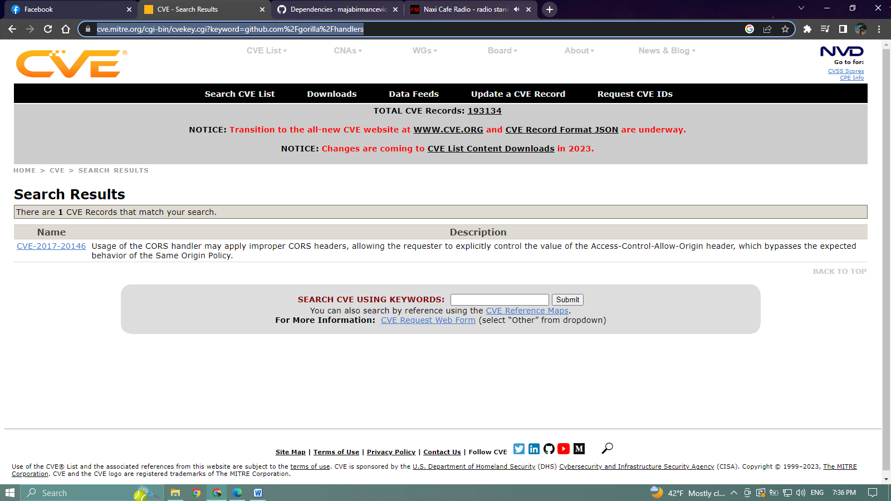**github.com/gorilla/handlers**
* 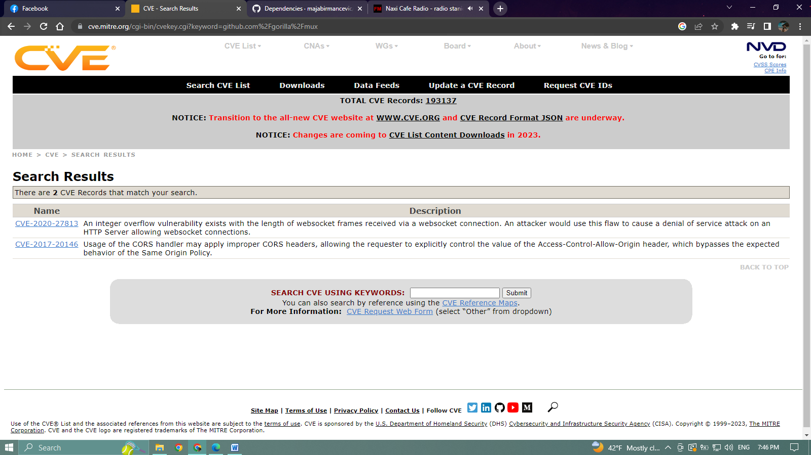**github.com/gorilla/mux**
* **github.com/k3a/html2text**

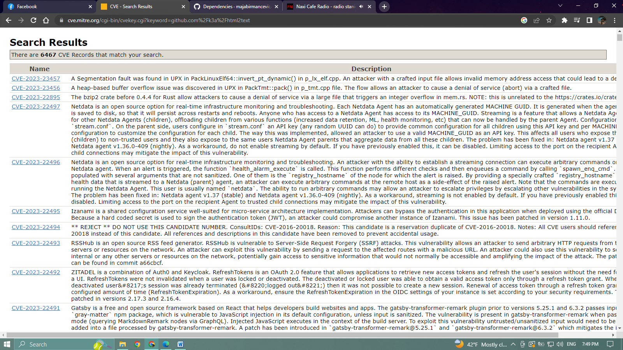**link:**[**https://cve.mitre.org/cgi-bin/cvekey.cgi?keyword=github.com%2Fk3a%2Fhtml2text**](https://cve.mitre.org/cgi-bin/cvekey.cgi?keyword=github.com%2Fk3a%2Fhtml2text)

* **github.com/klauspost/compress**

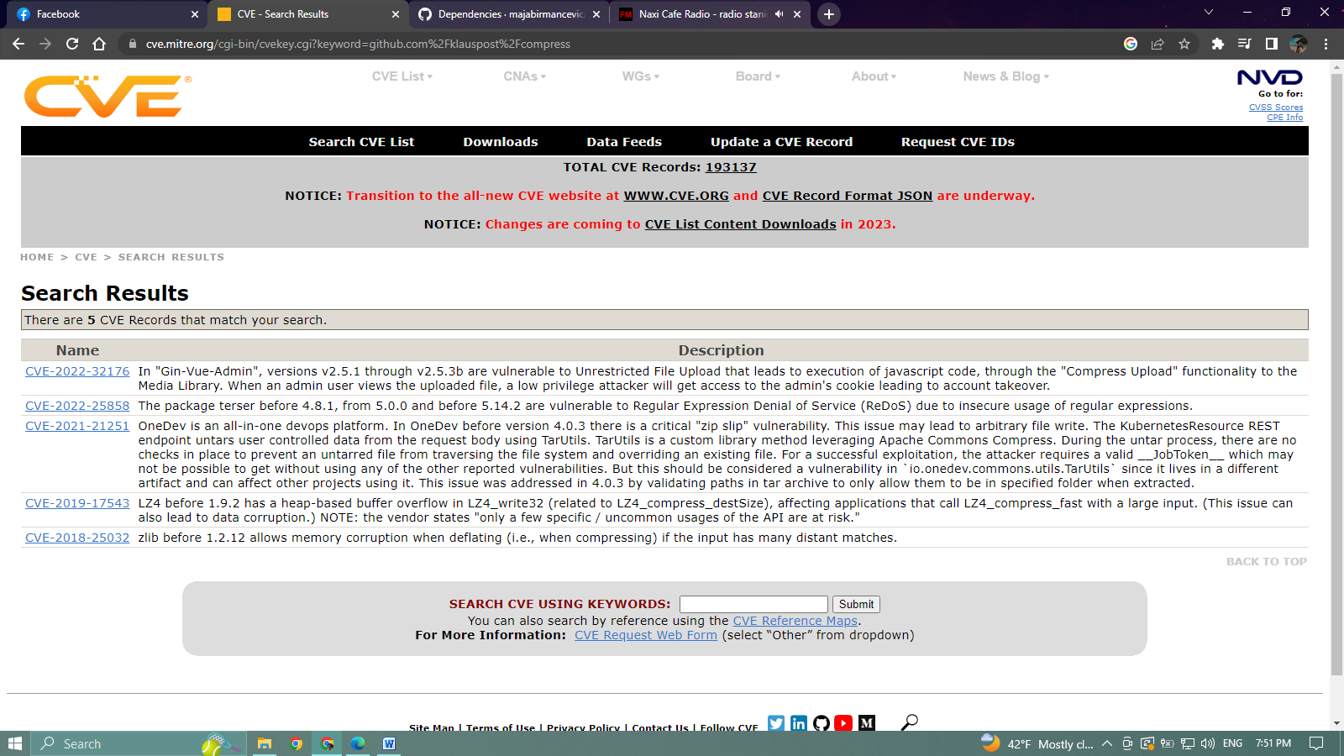

* **github.com/kr/pretty**

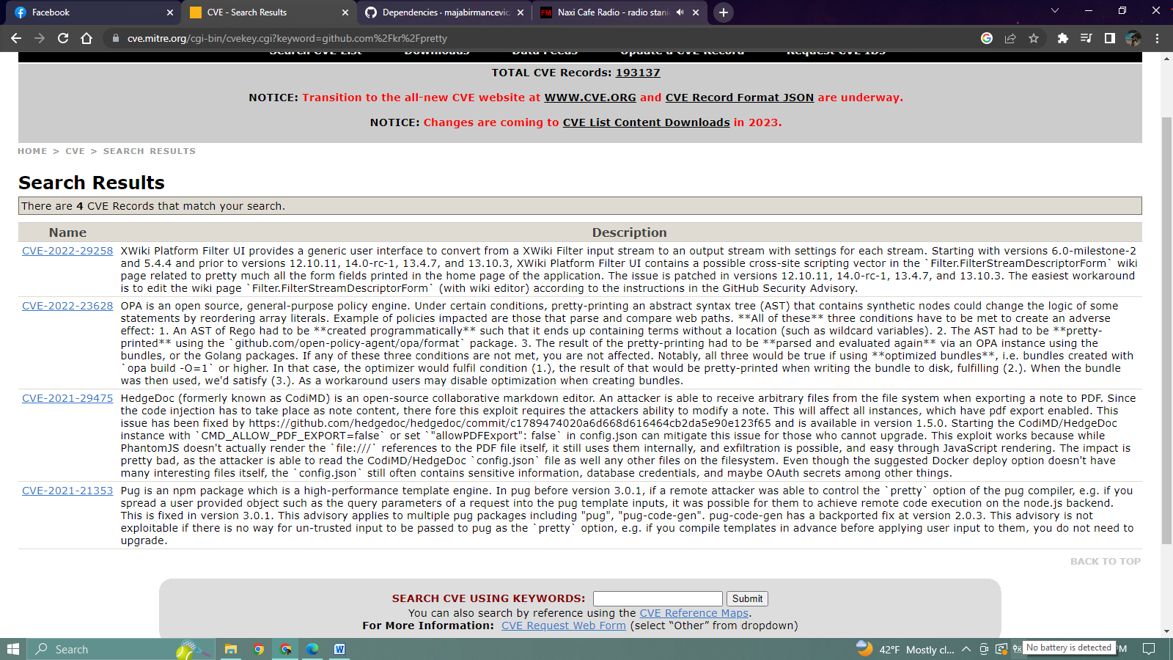

* **github.com/montanaflynn/stats**

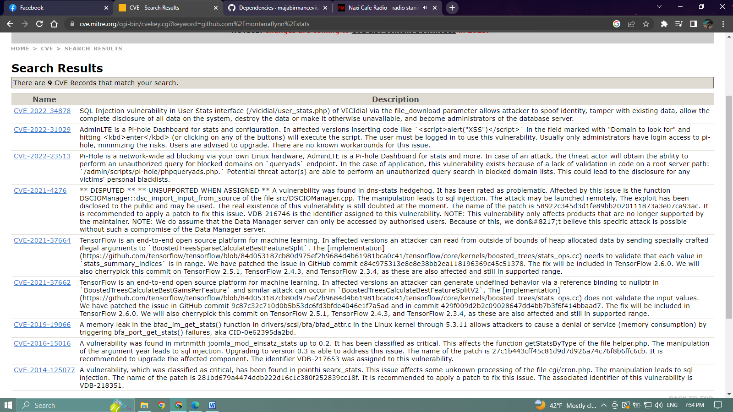

* **github.com/pkg/errors**

**link:** [**https://cve.mitre.org/cgi-bin/cvekey.cgi?keyword=github.com%2Fpkg%2Ferrors**](https://cve.mitre.org/cgi-bin/cvekey.cgi?keyword=github.com%2Fpkg%2Ferrors)

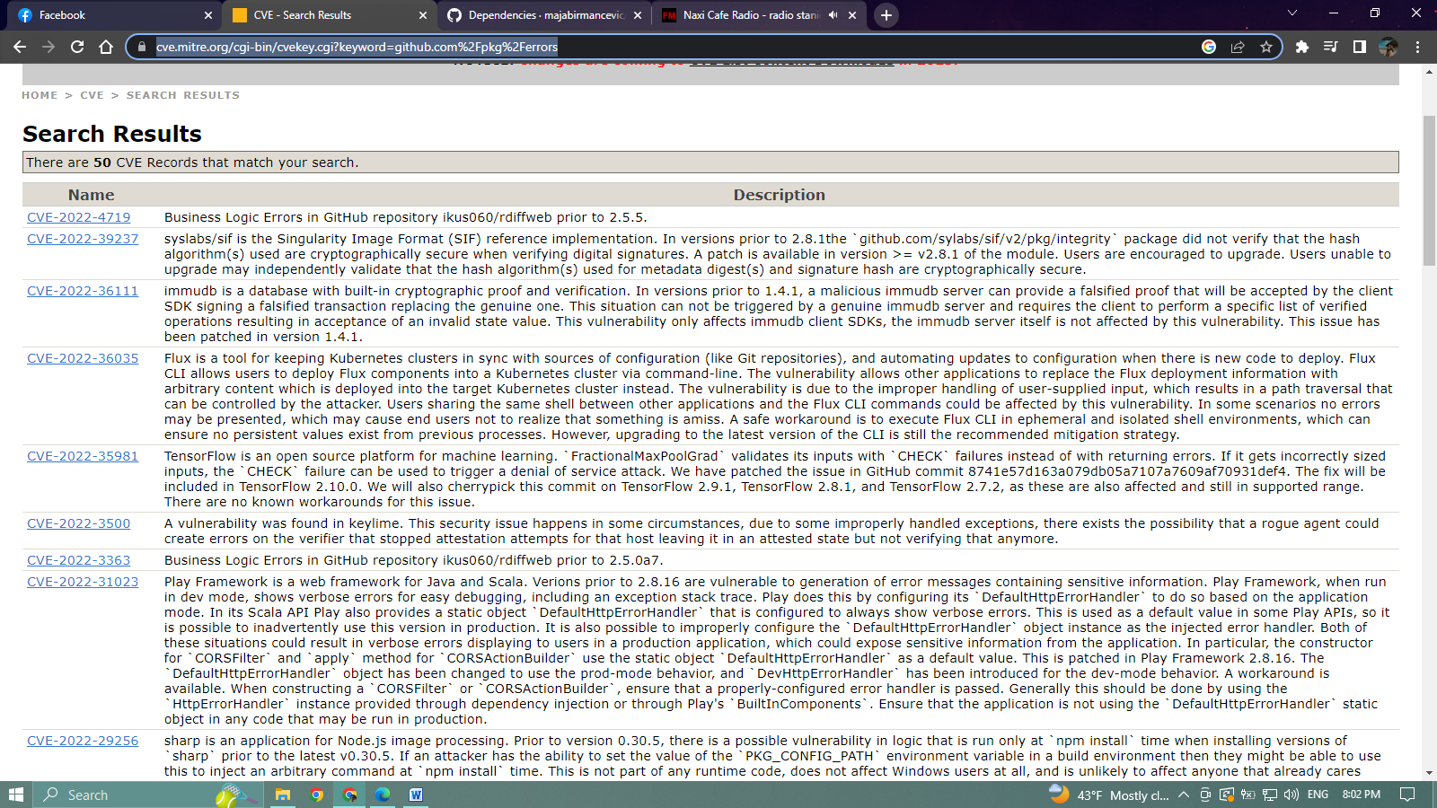

* **github.com/stretchr/testify**

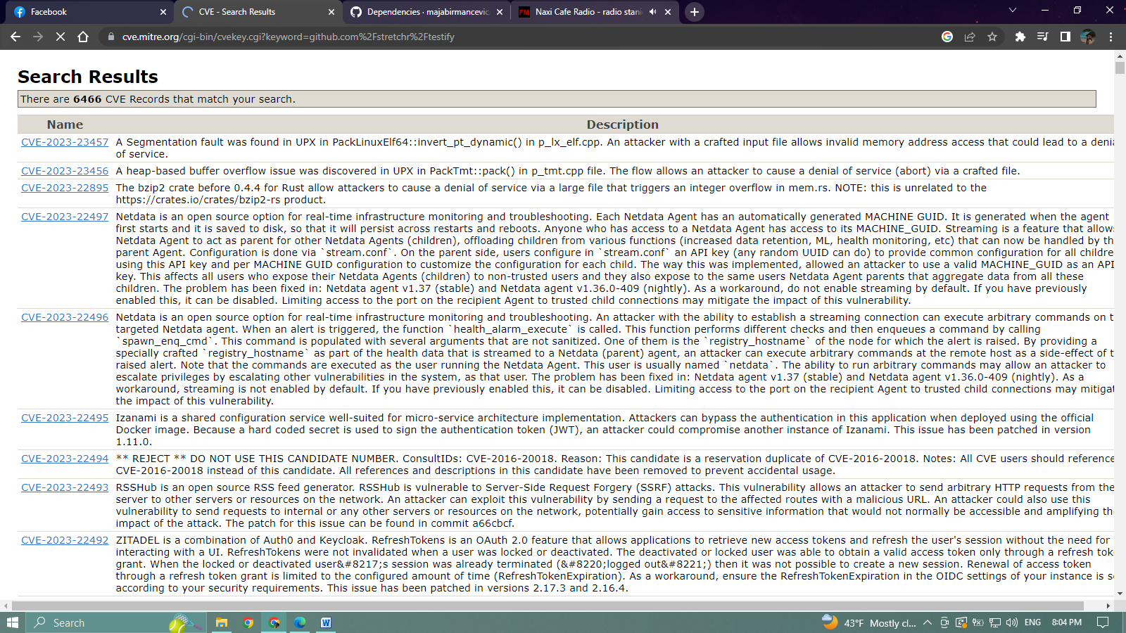**link:** [**https://cve.mitre.org/cgi-bin/cvekey.cgi?keyword=github.com%2Fstretchr%2Ftestify**](https://cve.mitre.org/cgi-bin/cvekey.cgi?keyword=github.com%2Fstretchr%2Ftestify)

* 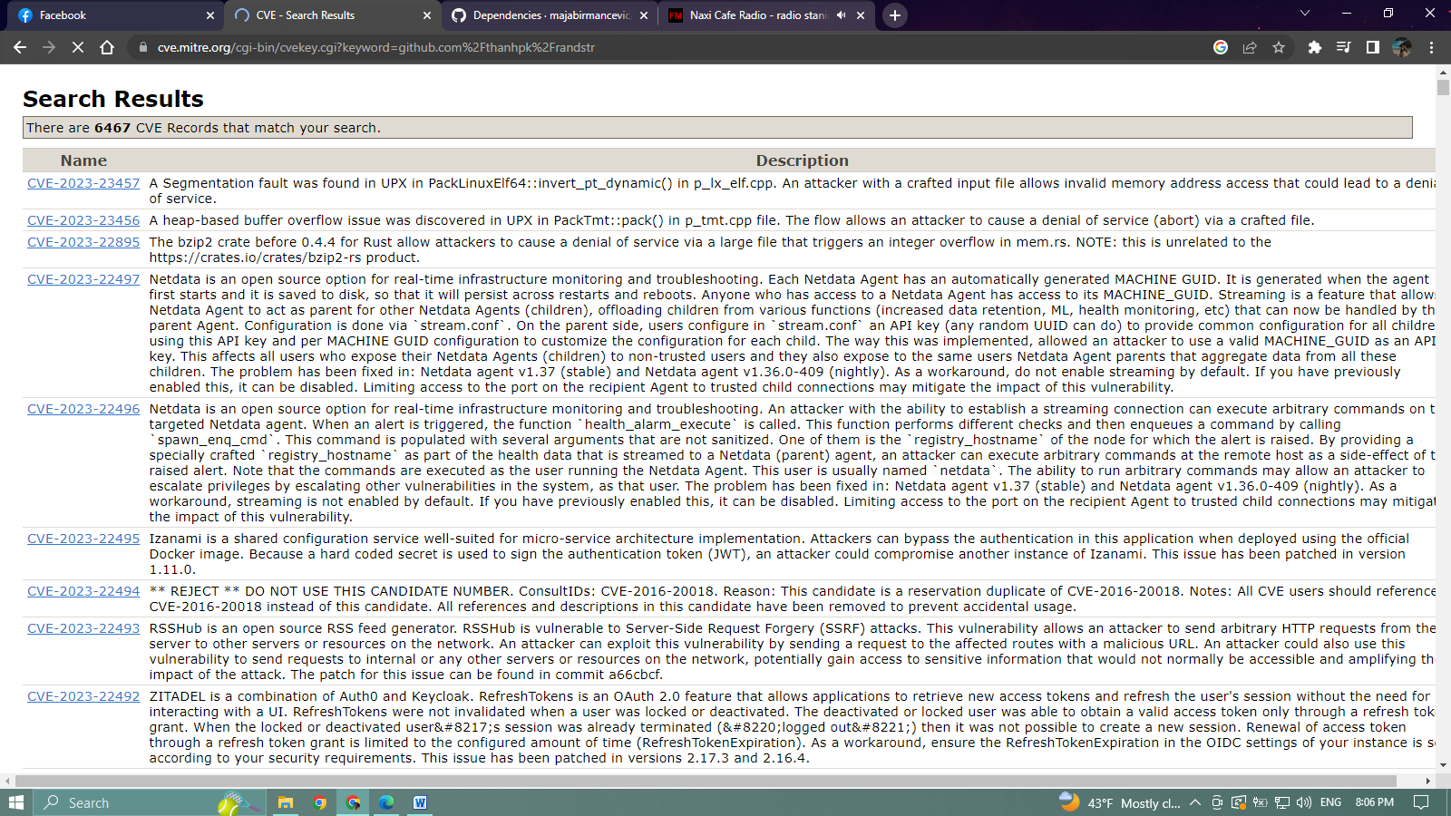**github.com/thanhpk/randstr**

**link:**[**https://cve.mitre.org/cgi-bin/cvekey.cgi?keyword=github.com%2Fthanhpk%2Frandstr**](https://cve.mitre.org/cgi-bin/cvekey.cgi?keyword=github.com%2Fthanhpk%2Frandstr)

* **github.com/xdg-go/pbkdf2**

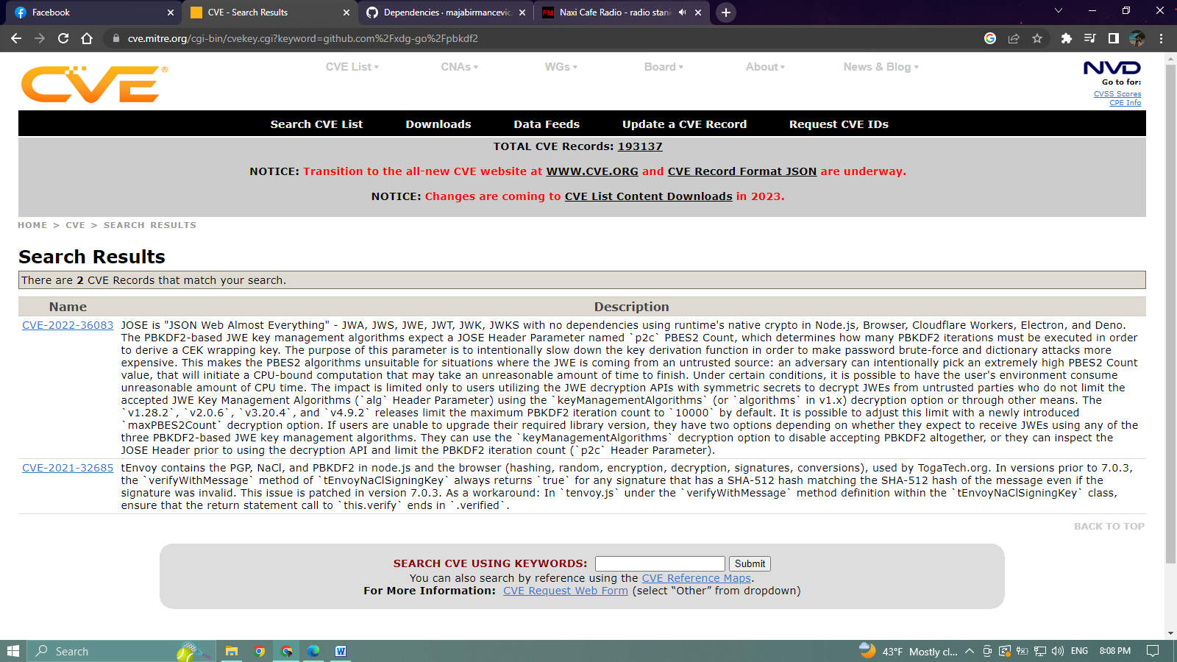

* **github.com/xdg-go/scram**

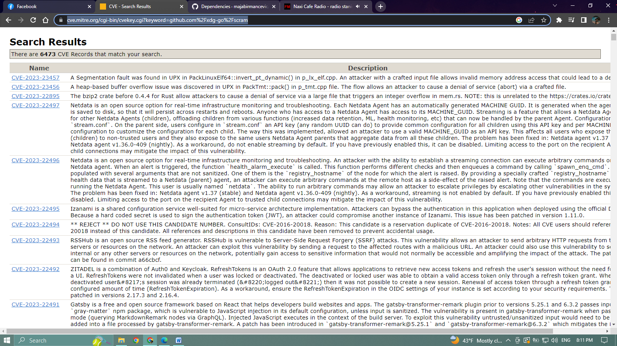**link:**[**https://cve.mitre.org/cgi-bin/cvekey.cgi?keyword=github.com%2Fxdg-go%2Fscram**](https://cve.mitre.org/cgi-bin/cvekey.cgi?keyword=github.com%2Fxdg-go%2Fscram)

* **github.com/xdg-go/stringprep**

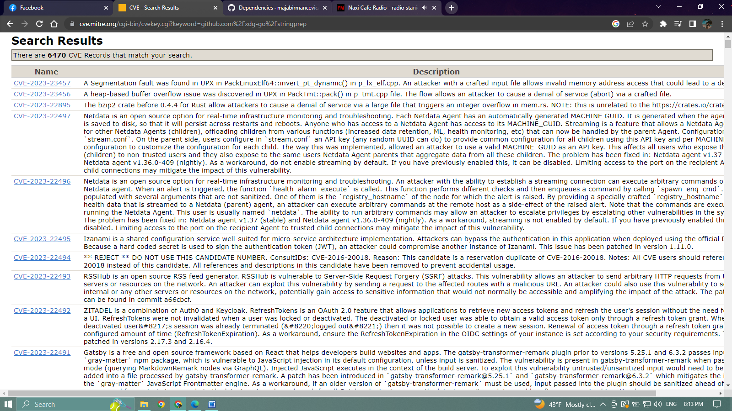**link:** [**https://cve.mitre.org/cgi-bin/cvekey.cgi?keyword=github.com%2Fxdg-go%2Fstringprep**](https://cve.mitre.org/cgi-bin/cvekey.cgi?keyword=github.com%2Fxdg-go%2Fstringprep)

* **github.com/youmark/pkcs8**

**link:**[**https://cve.mitre.org/cgi-bin/cvekey.cgi?keyword=github.com%2Fyoumark%2Fpkcs8**](https://cve.mitre.org/cgi-bin/cvekey.cgi?keyword=github.com%2Fyoumark%2Fpkcs8)

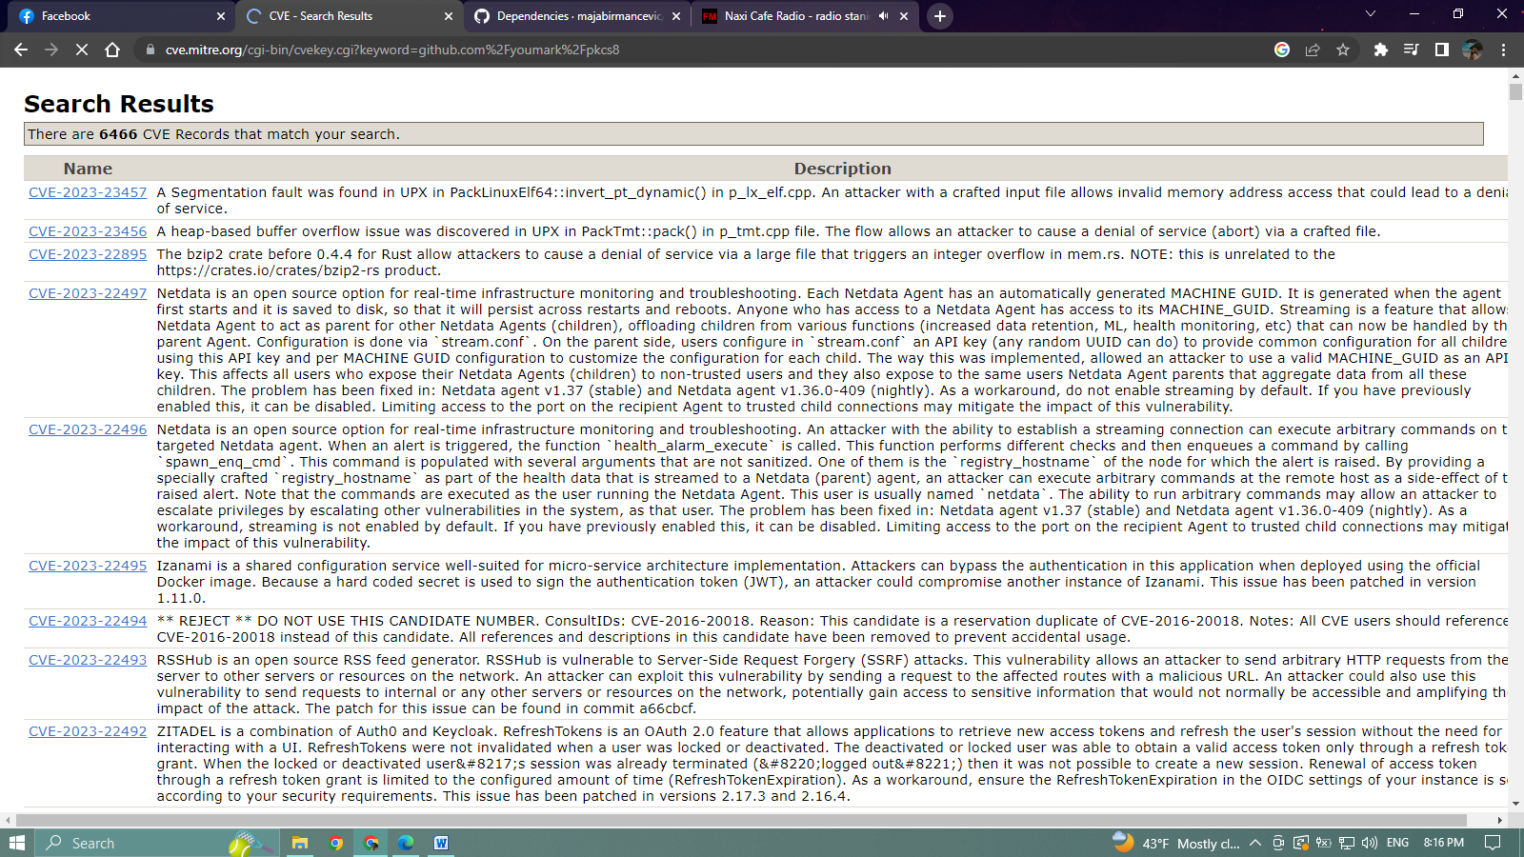

* 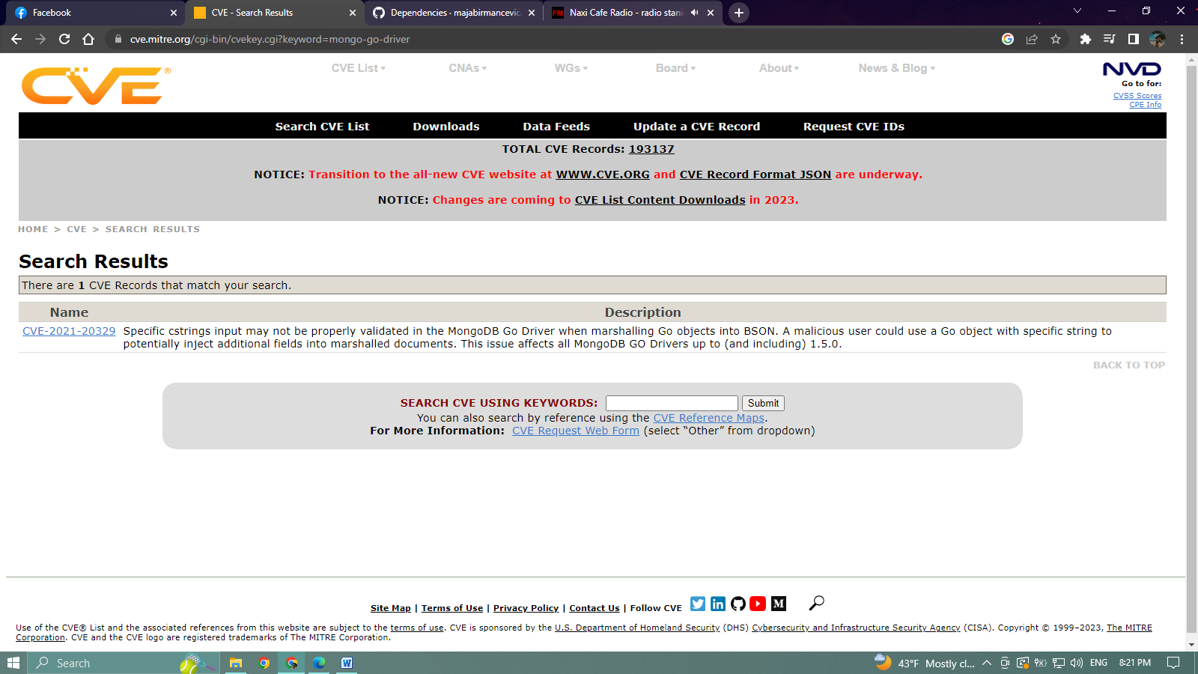**go.mongodb.org/mongo-driver**
* 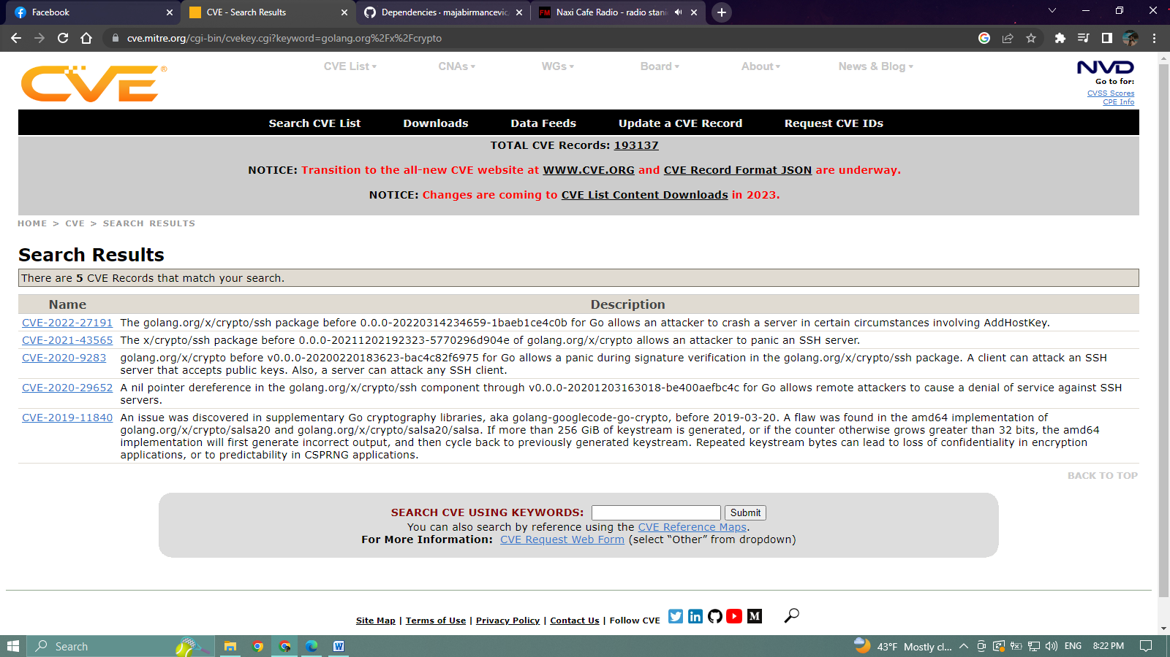**golang.org/x/crypto**
* 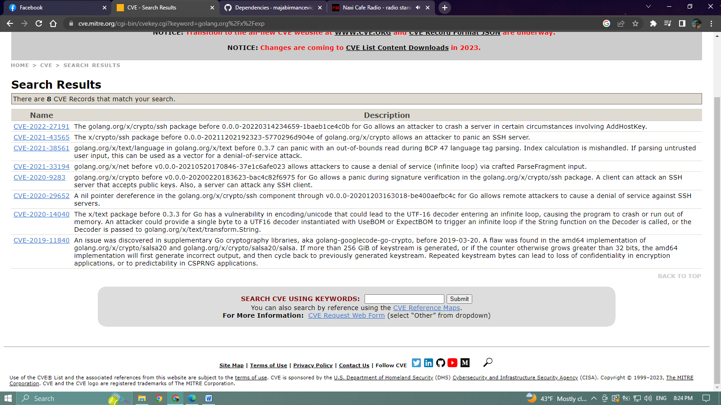**golang.org/x/exp**
* **golang.org/x/sync**

**link:** [**https://cve.mitre.org/cgi-bin/cvekey.cgi?keyword=golang.org%2Fx%2Fsync**](https://cve.mitre.org/cgi-bin/cvekey.cgi?keyword=golang.org%2Fx%2Fsync)

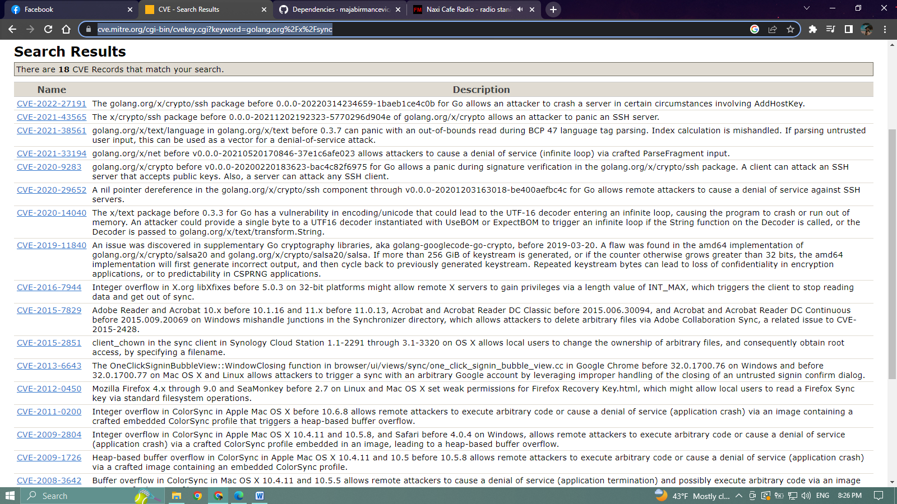

* 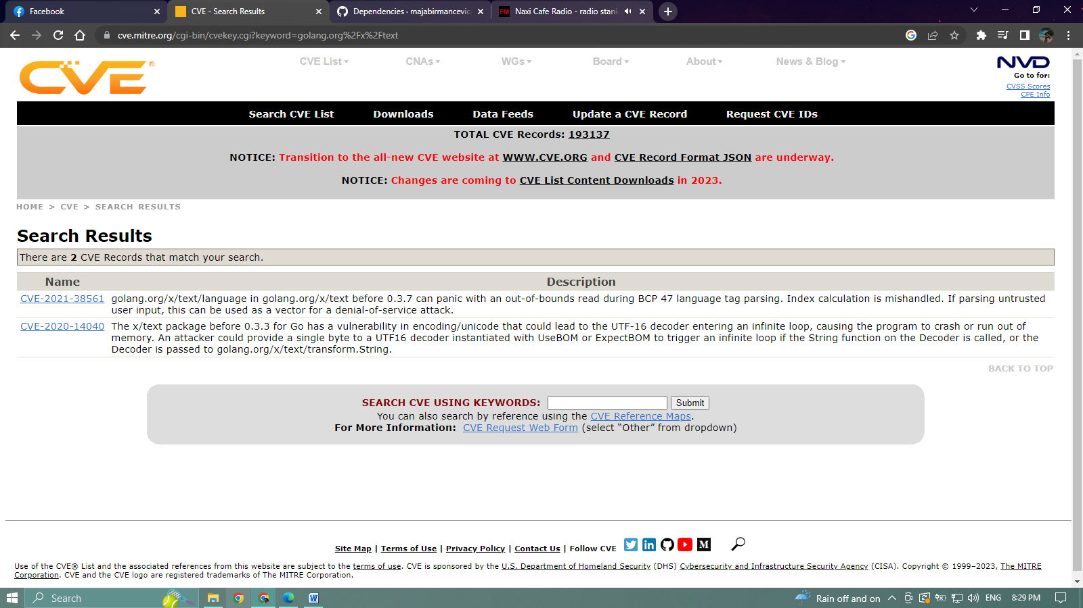**golang.org/x/text**

Dependencies defined in tweet_**service/go.mod**

* **github.com/felixge/httpsnoop**

**link:** [**https://cve.mitre.org/cgi-bin/cvekey.cgi?keyword=github.com%2Ffelixge%2Fhttpsnoop**](https://cve.mitre.org/cgi-bin/cvekey.cgi?keyword=github.com%2Ffelixge%2Fhttpsnoop)

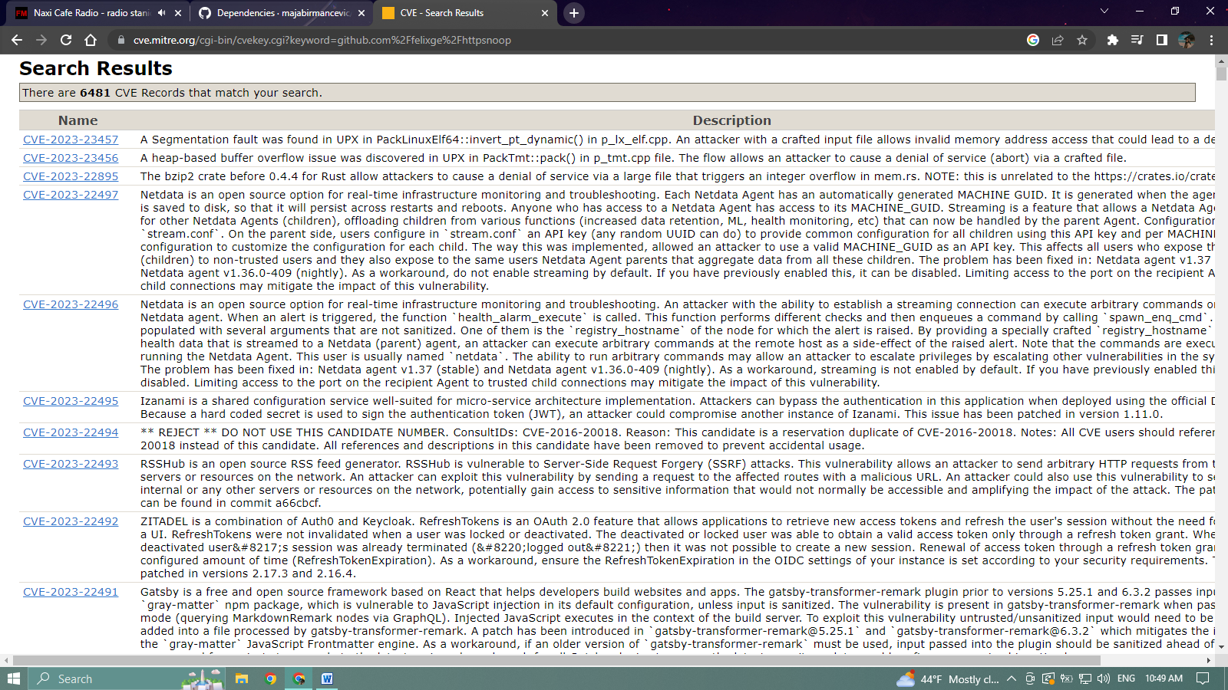

* **github.com/gocql/gocql**

**link:** [**https://cve.mitre.org/cgi-bin/cvekey.cgi?keyword=github.com%2Fgocql%2Fgocql**](https://cve.mitre.org/cgi-bin/cvekey.cgi?keyword=github.com%2Fgocql%2Fgocql)

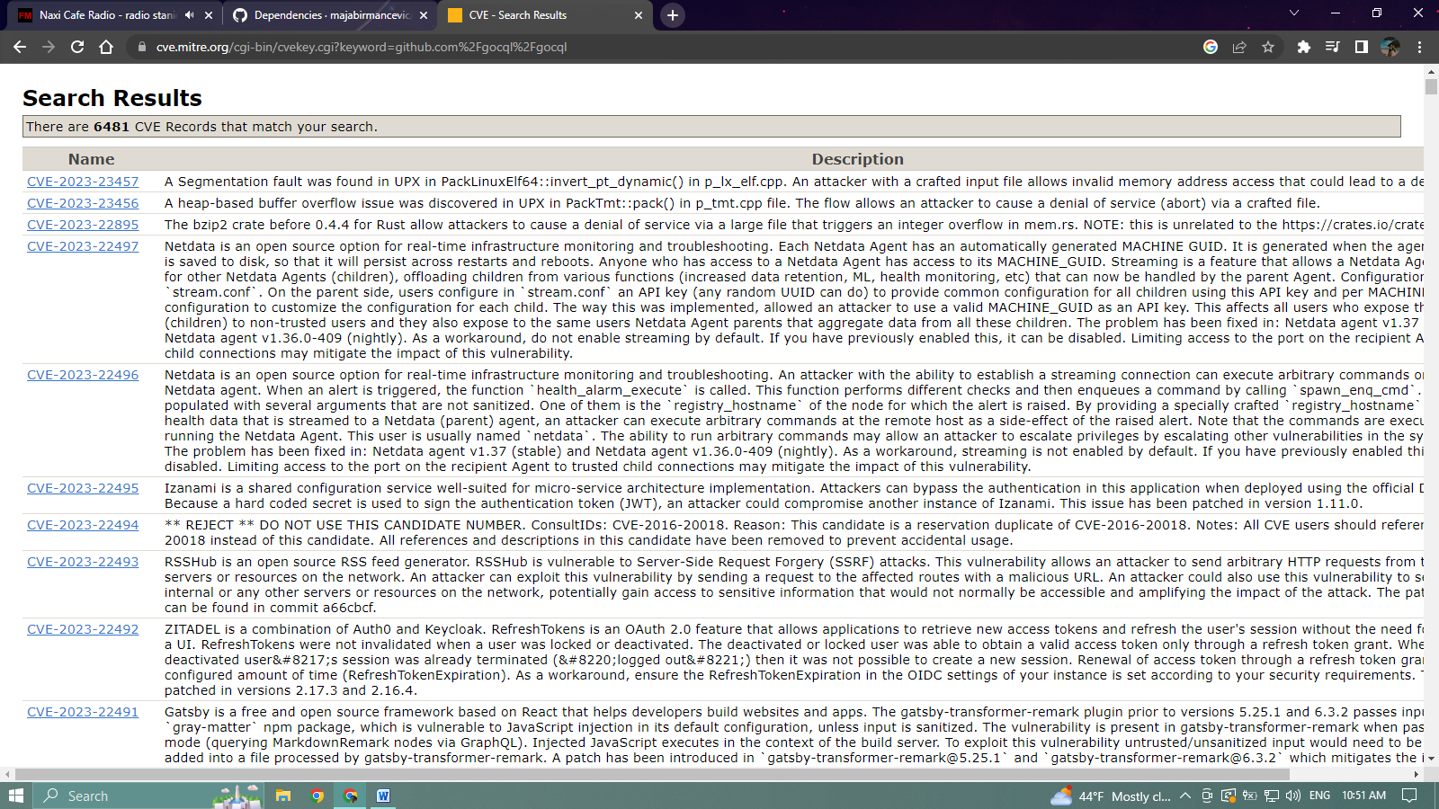

* **github.com/hailocab/go-hostpool**

**link:** [**https://cve.mitre.org/cgi-bin/cvekey.cgi?keyword=github.com%2Fhailocab%2Fgo-hostpool**](https://cve.mitre.org/cgi-bin/cvekey.cgi?keyword=github.com%2Fhailocab%2Fgo-hostpool)

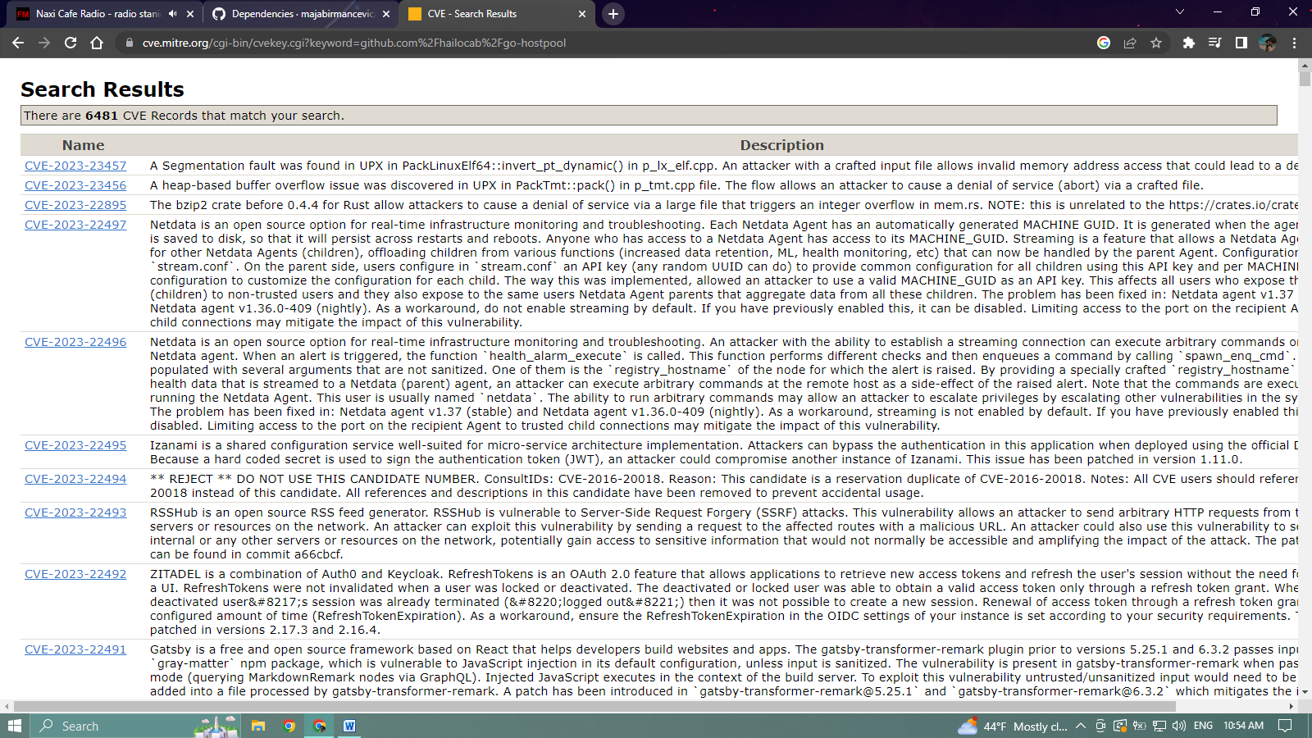

* **github.com/satori/go.uuid**

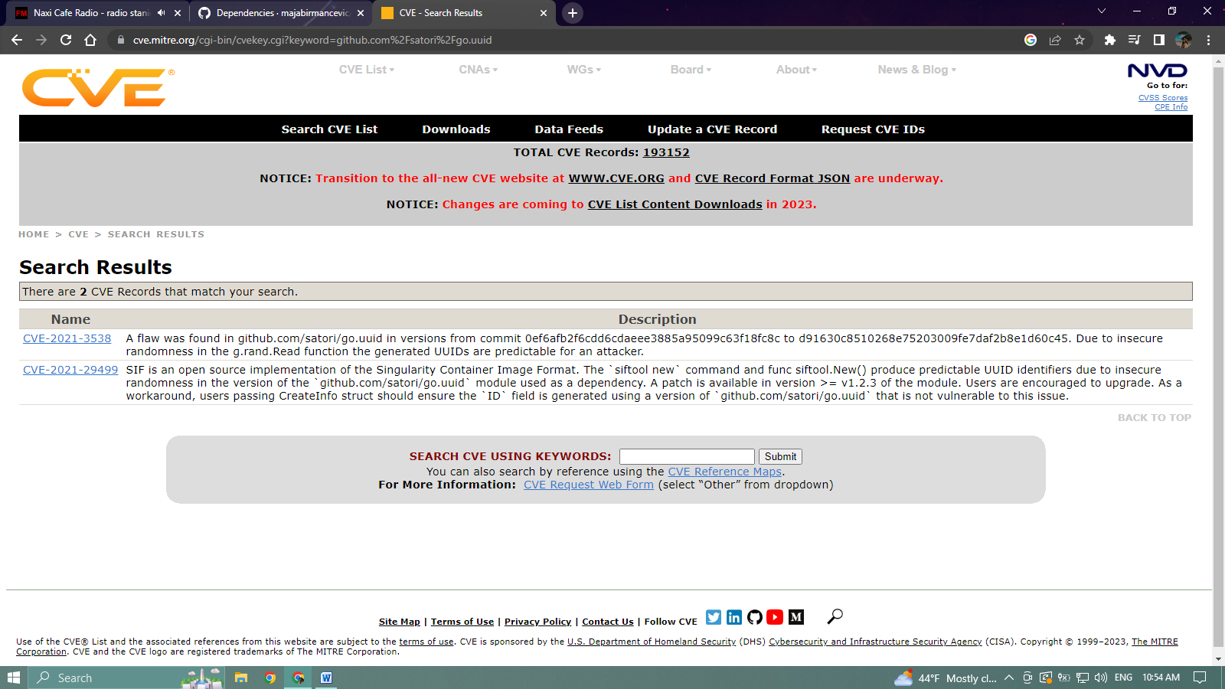

* **gopkg.in/check.v1**

**link:** [**https://cve.mitre.org/cgi-bin/cvekey.cgi?keyword=gopkg.in%2Fcheck.v1**](https://cve.mitre.org/cgi-bin/cvekey.cgi?keyword=gopkg.in%2Fcheck.v1)

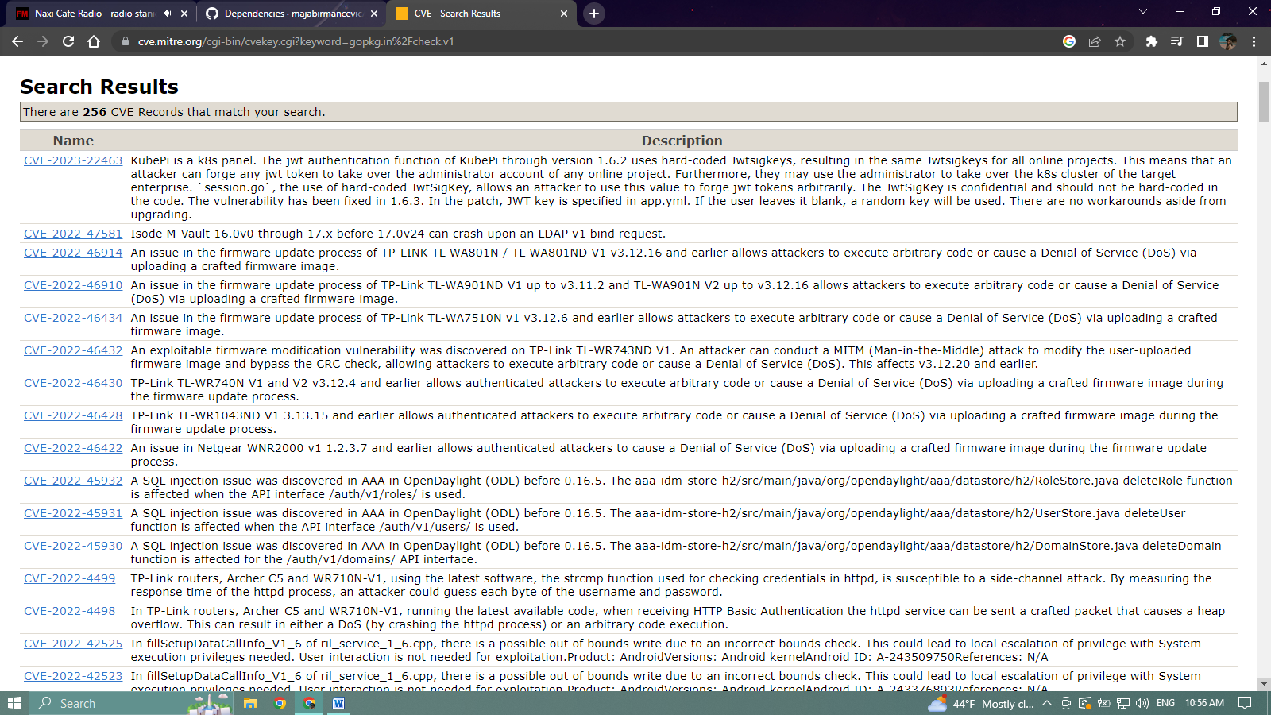

Dependencies defined in **profile_service/go.mod**

* 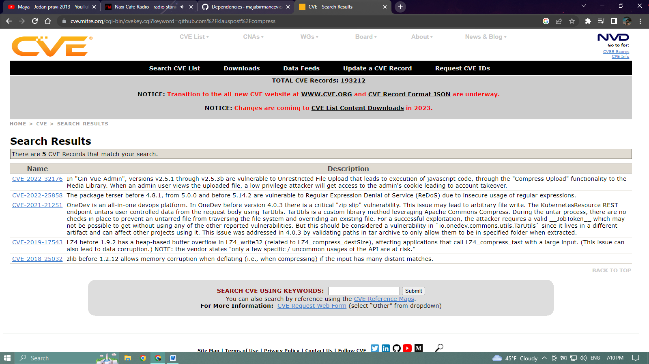**github.com/klauspost/compress**
* **github.com/montanaflynn/stats**

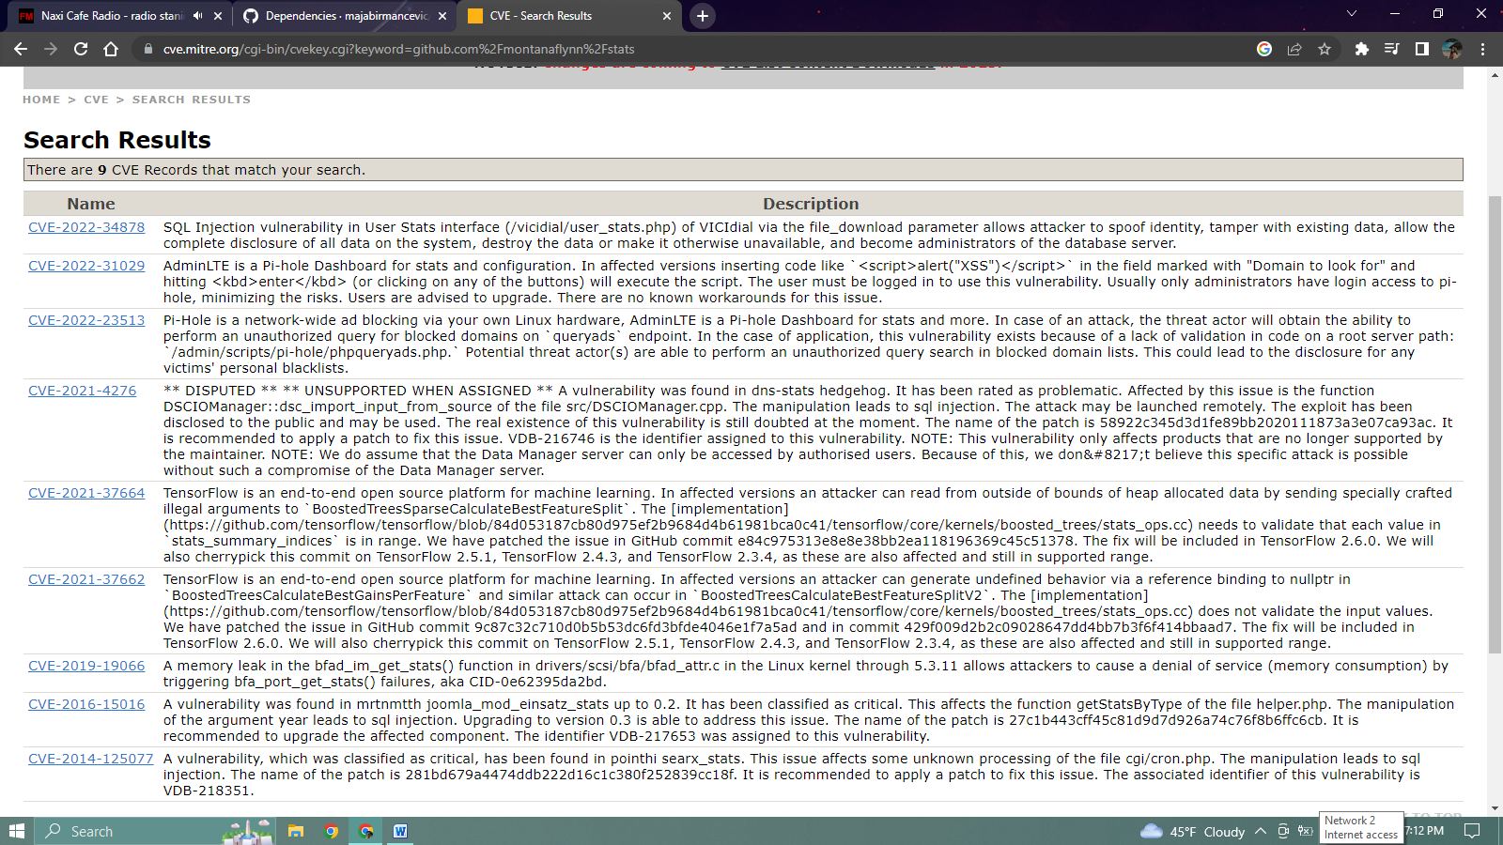

* github.com/pkg/errors

**link:** [**https://cve.mitre.org/cgi-bin/cvekey.cgi?keyword=github.com%2Fpkg%2Ferrors**](https://cve.mitre.org/cgi-bin/cvekey.cgi?keyword=github.com%2Fpkg%2Ferrors)

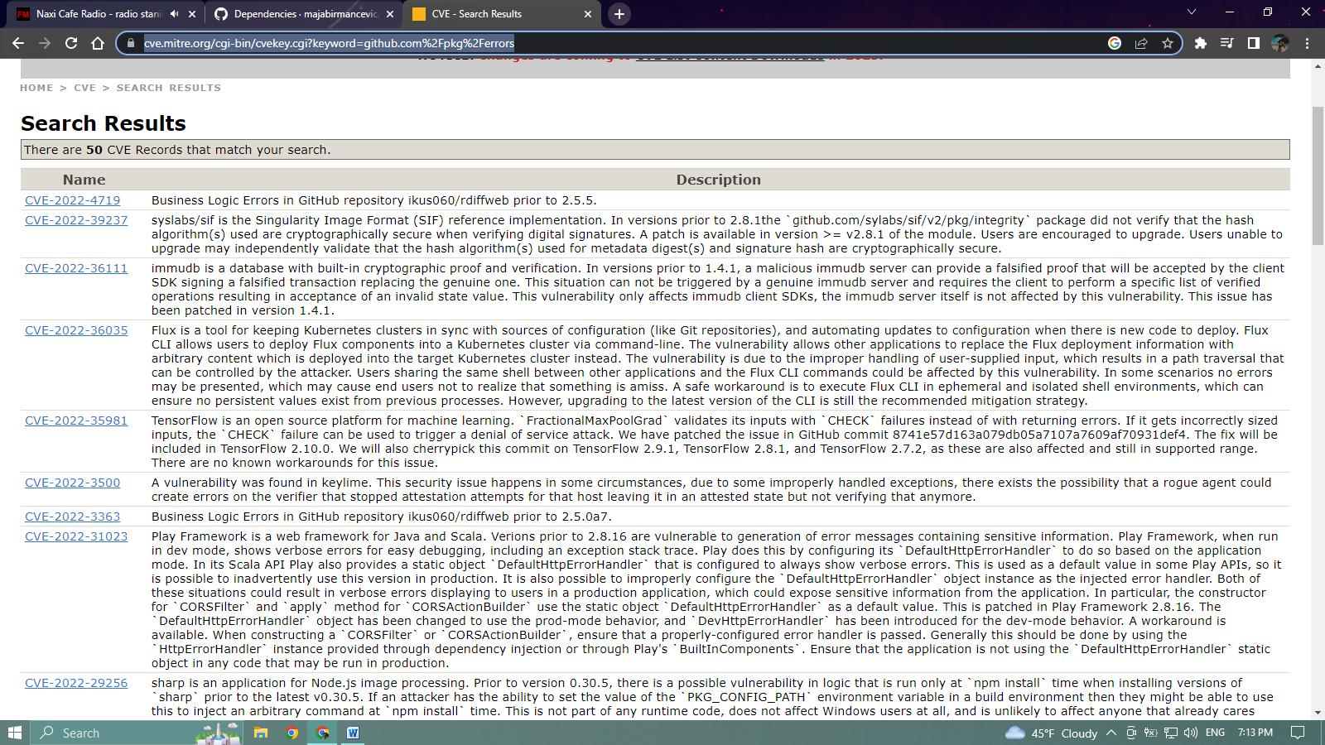

* **github.com/thanhpk/randstr**

**link:** [**https://cve.mitre.org/cgi-bin/cvekey.cgi?keyword=github.com%2Fthanhpk%2Frandstr**](https://cve.mitre.org/cgi-bin/cvekey.cgi?keyword=github.com%2Fthanhpk%2Frandstr)

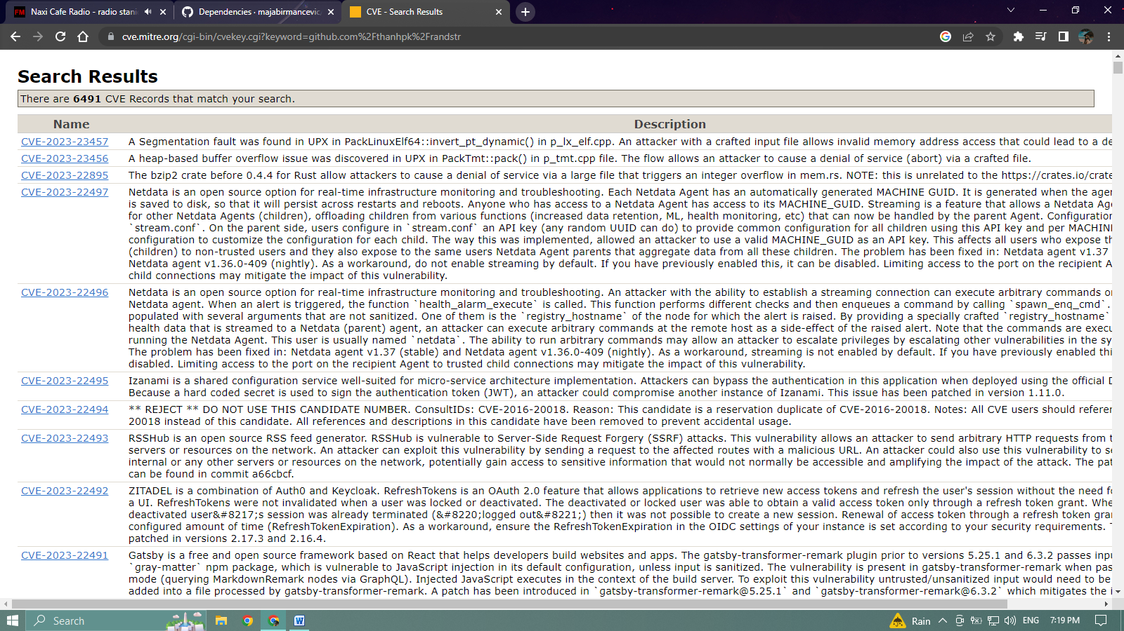

* **github.com/xdg-go/pbkdf2**

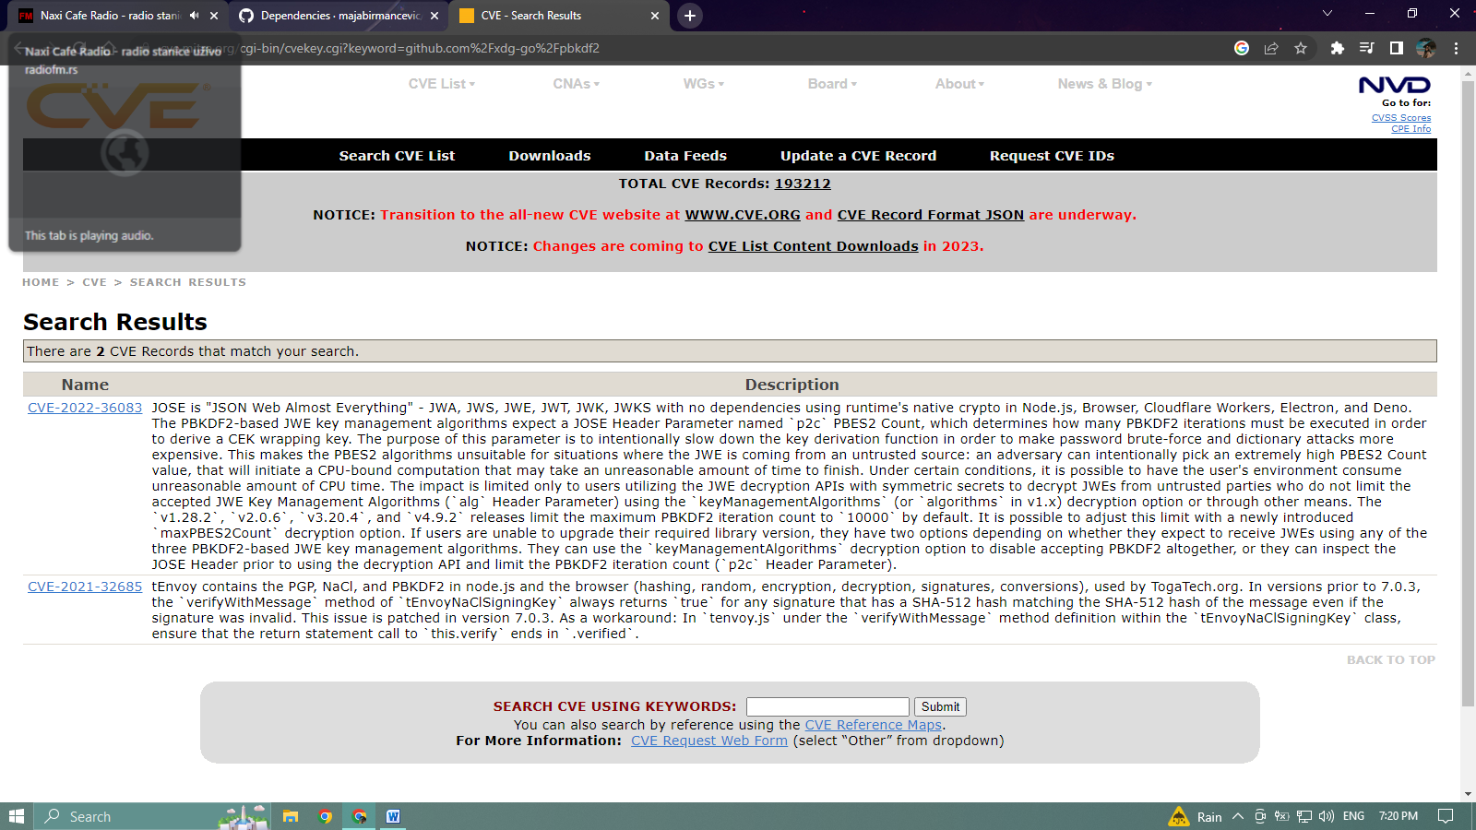

* **github.com/xdg-go/scram**

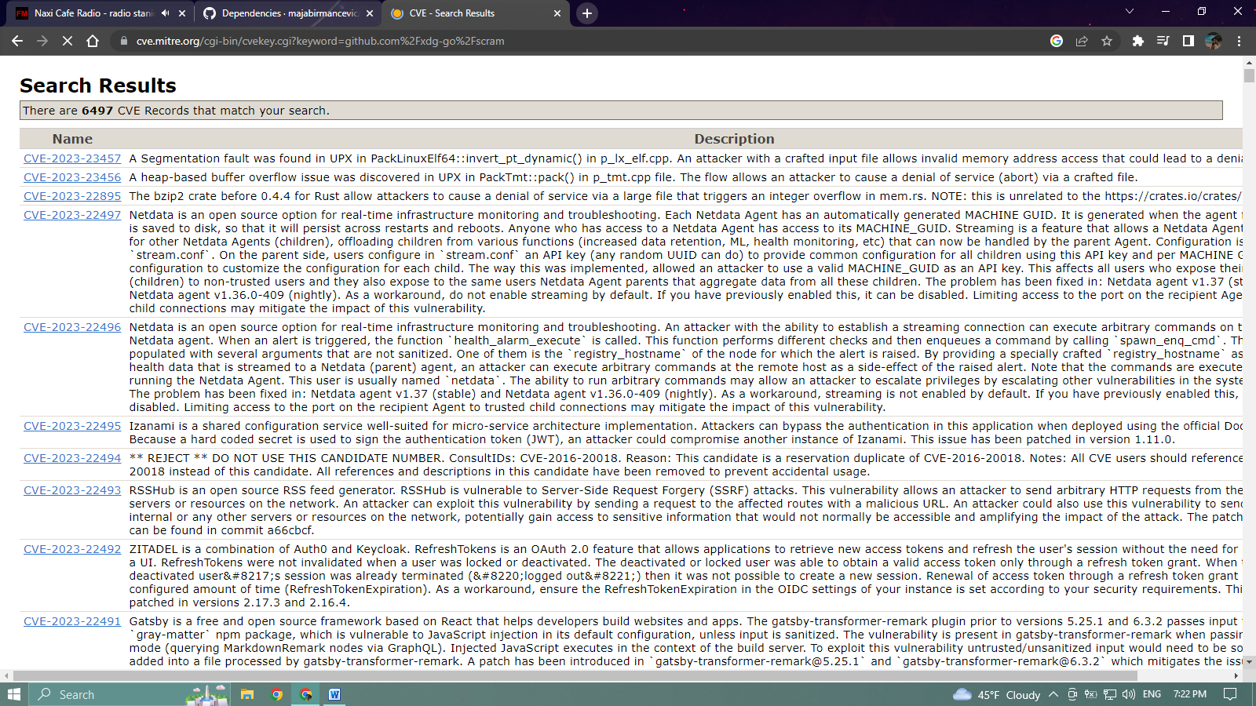

* **github.com/xdg-go/stringprep**

**link:** [**https://cve.mitre.org/cgi-bin/cvekey.cgi?keyword=github.com%2Fxdg-go%2Fstringprep**](https://cve.mitre.org/cgi-bin/cvekey.cgi?keyword=github.com%2Fxdg-go%2Fstringprep)

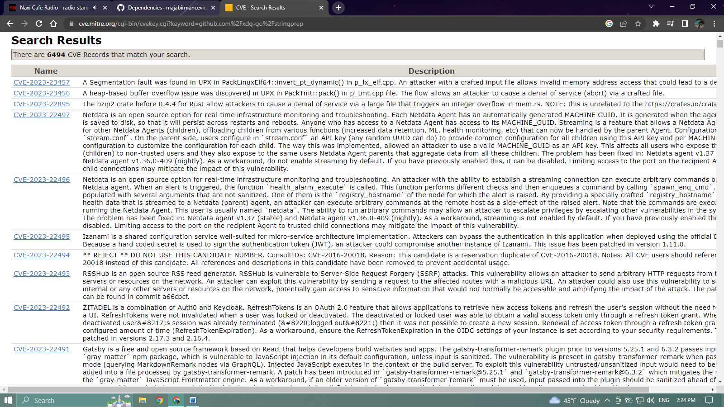

* **github.com/youmark/pkcs8**

**link:**[**https://cve.mitre.org/cgi-bin/cvekey.cgi?keyword=github.com%2Fyoumark%2Fpkcs8**](https://cve.mitre.org/cgi-bin/cvekey.cgi?keyword=github.com%2Fyoumark%2Fpkcs8)

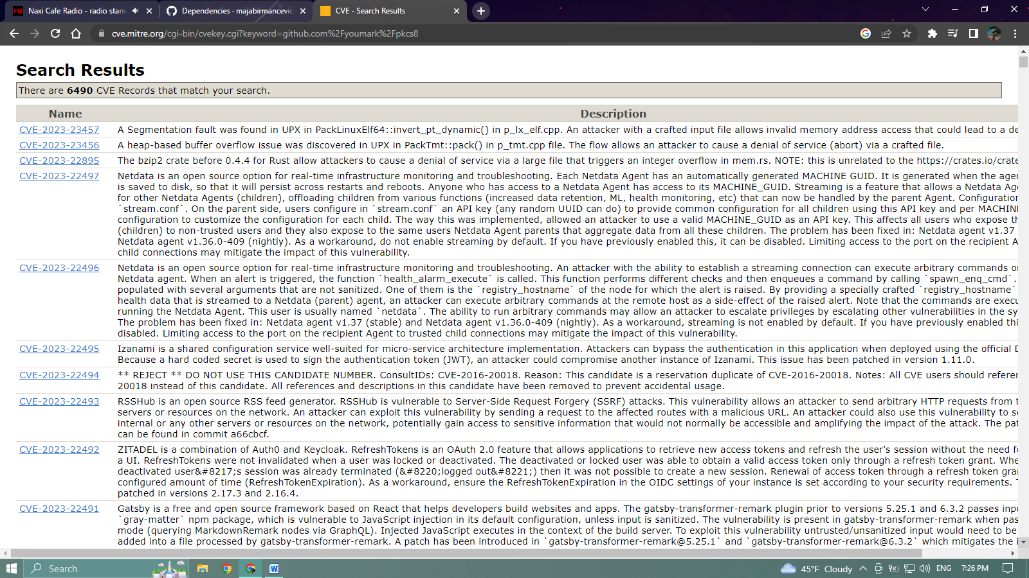

* 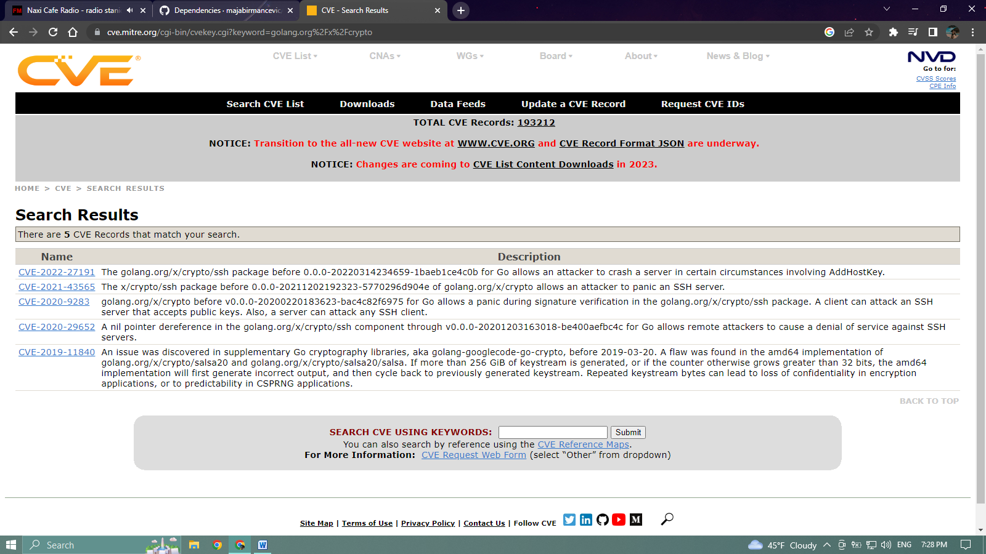**golang.org/x/crypto**
* **golang.org/x/sync**

**link:** [**https://cve.mitre.org/cgi-bin/cvekey.cgi?keyword=golang.org%2Fx%2Fsync**](https://cve.mitre.org/cgi-bin/cvekey.cgi?keyword=golang.org%2Fx%2Fsync)

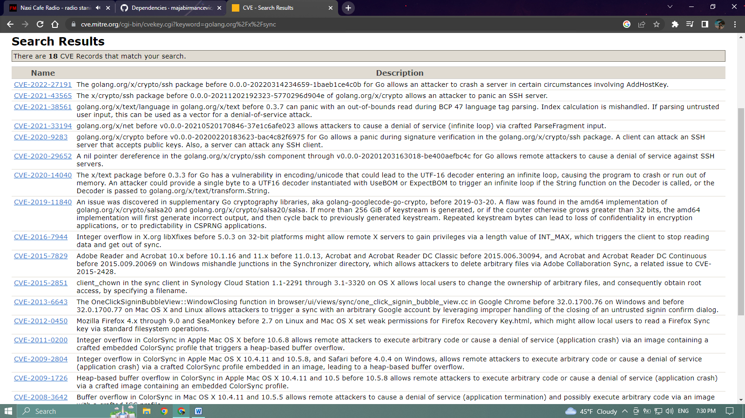

* **golang.org/x/text**

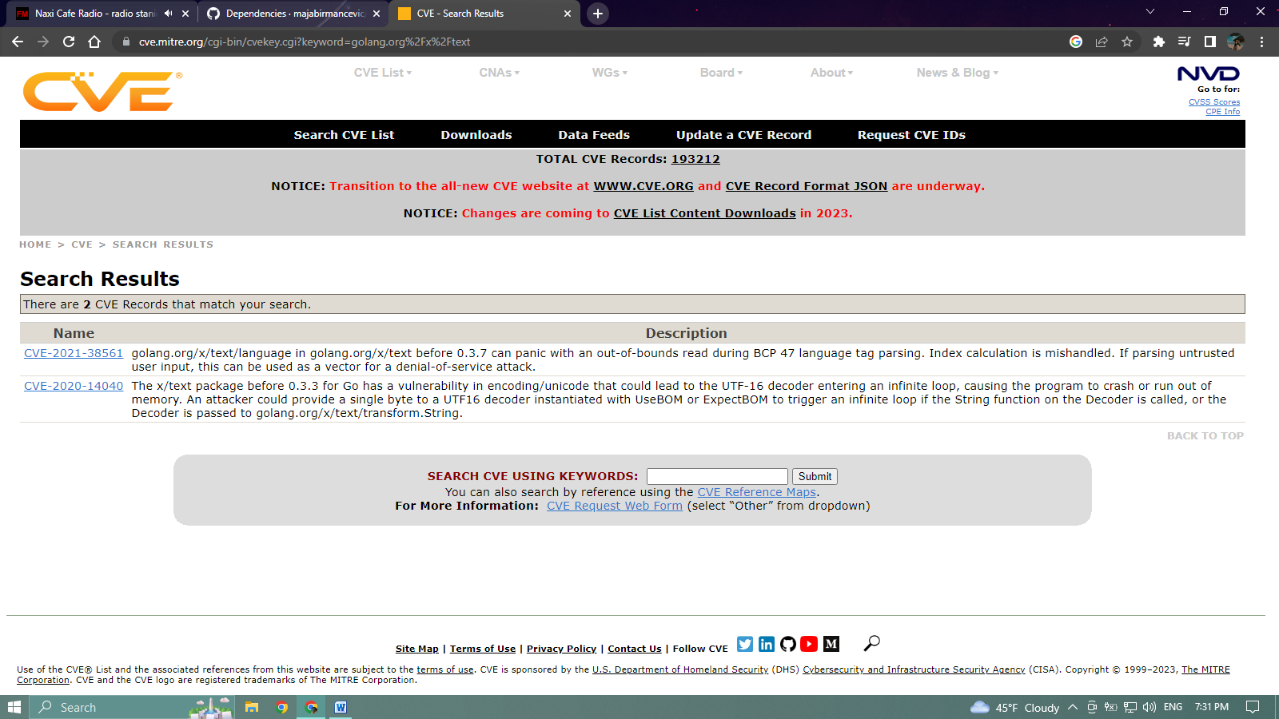

Dependencies defined in **frontend/package.json**

* **angular / angular-cli**

**link:** [**https://cve.mitre.org/cgi-bin/cvekey.cgi?keyword=+angular+%2F+angular-cli+**](https://cve.mitre.org/cgi-bin/cvekey.cgi?keyword=+angular+%2F+angular-cli+)

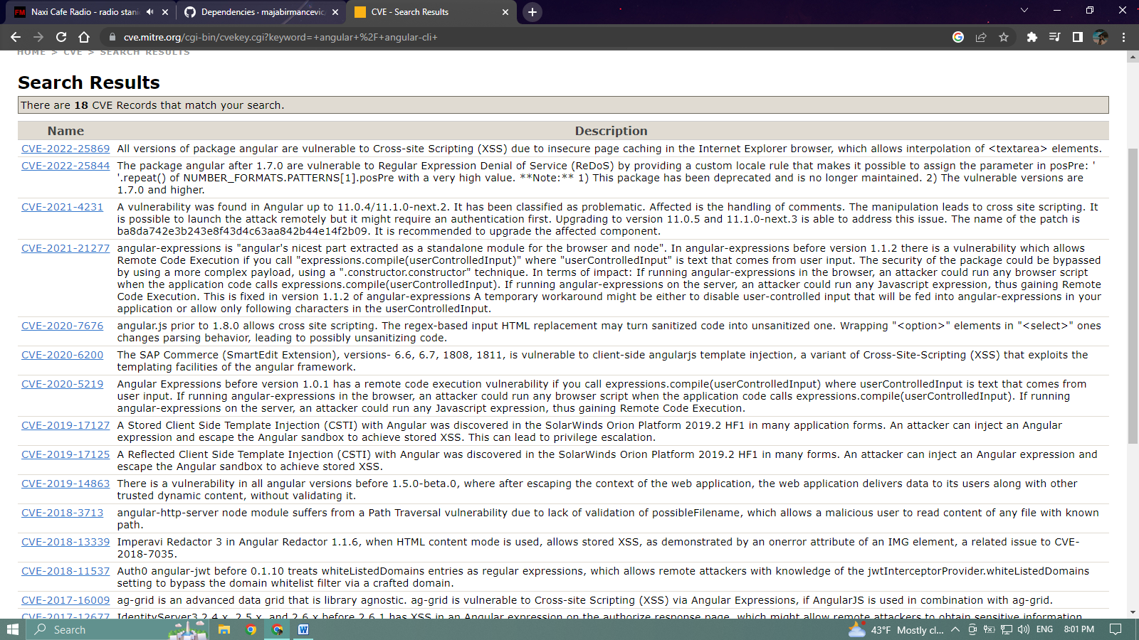

* **angular/animations**

**link:** [**https://cve.mitre.org/cgi-bin/cvekey.cgi?keyword=angular%2Fanimations**](https://cve.mitre.org/cgi-bin/cvekey.cgi?keyword=angular%2Fanimations)

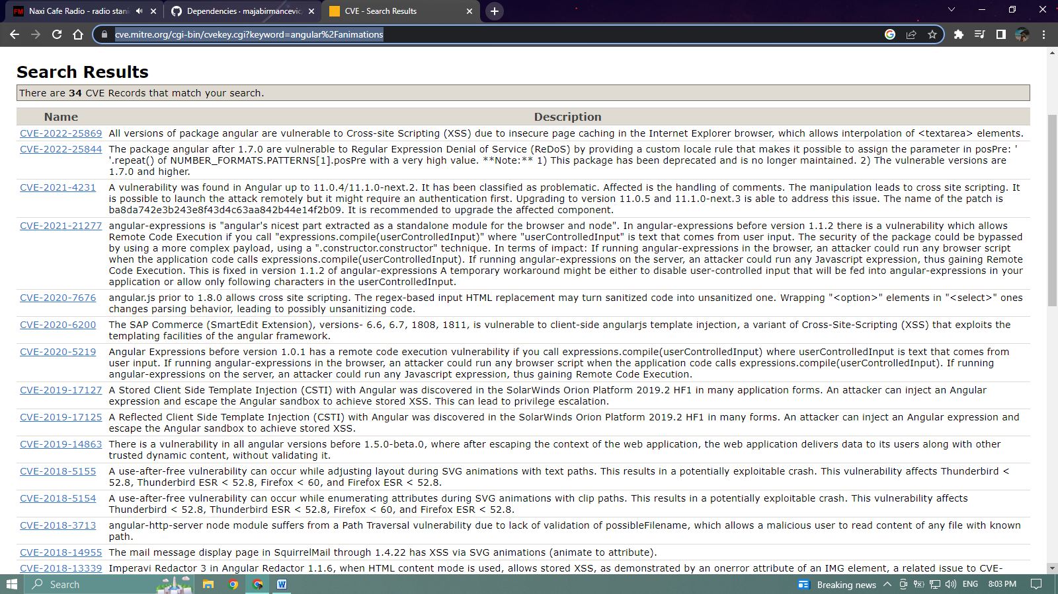

* **angular/common**

**link:** [**https://cve.mitre.org/cgi-bin/cvekey.cgi?keyword=angular%2Fcommon**](https://cve.mitre.org/cgi-bin/cvekey.cgi?keyword=angular%2Fcommon)

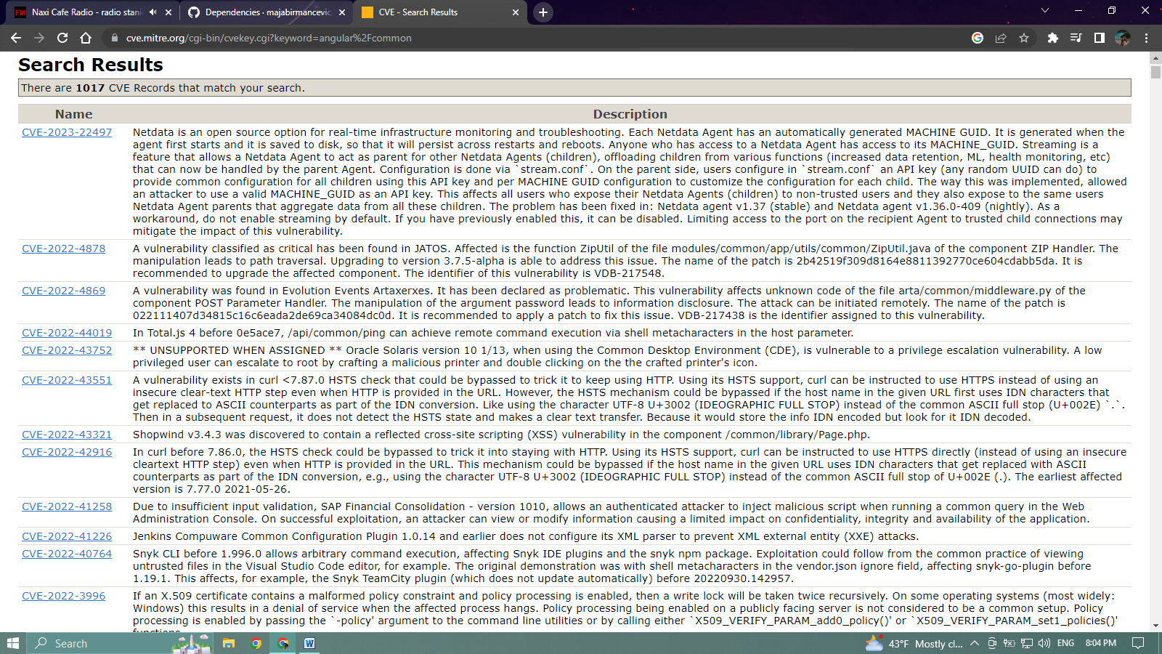

* **angular/forms**

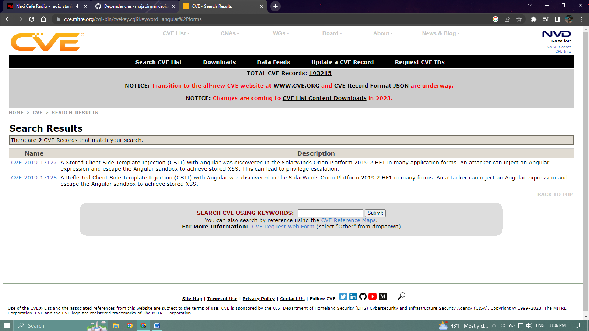

* **angular/platform-browser**

**link:** [**https://github.com/majabirmancevic/twitter-clone/network/dependencies**](https://github.com/majabirmancevic/twitter-clone/network/dependencies)

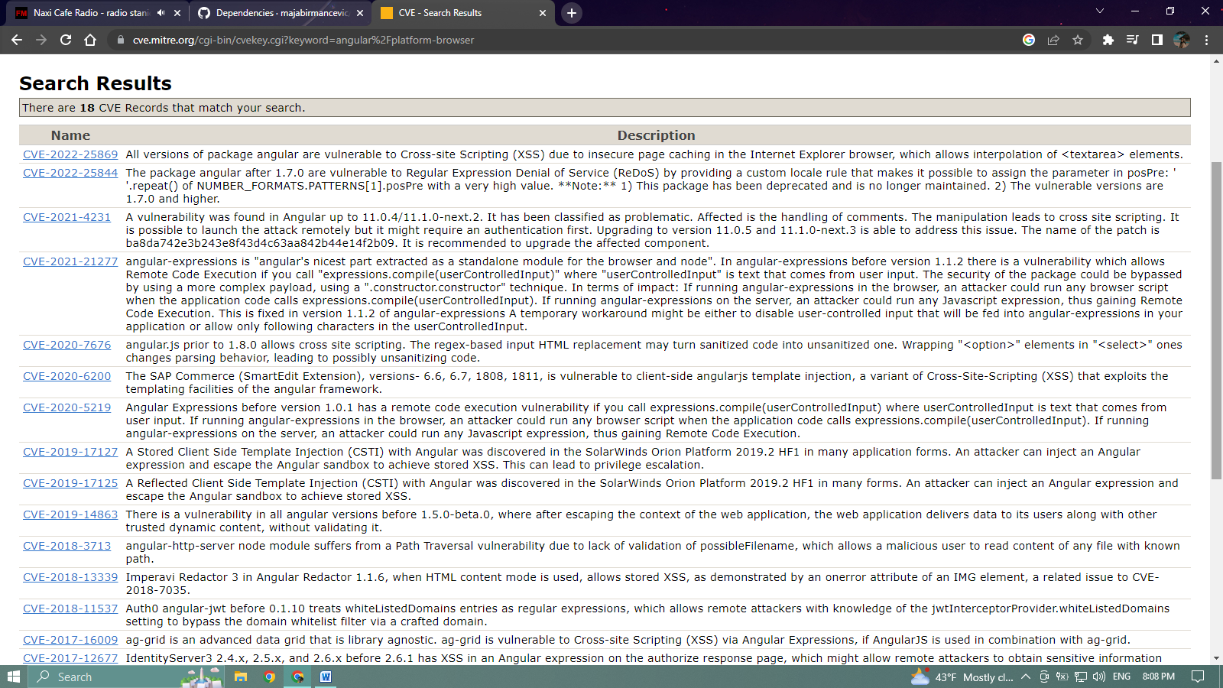

* **angular/router**

**link:** [**https://cve.mitre.org/cgi-bin/cvekey.cgi?keyword=angular%2Frouter**](https://cve.mitre.org/cgi-bin/cvekey.cgi?keyword=angular%2Frouter)

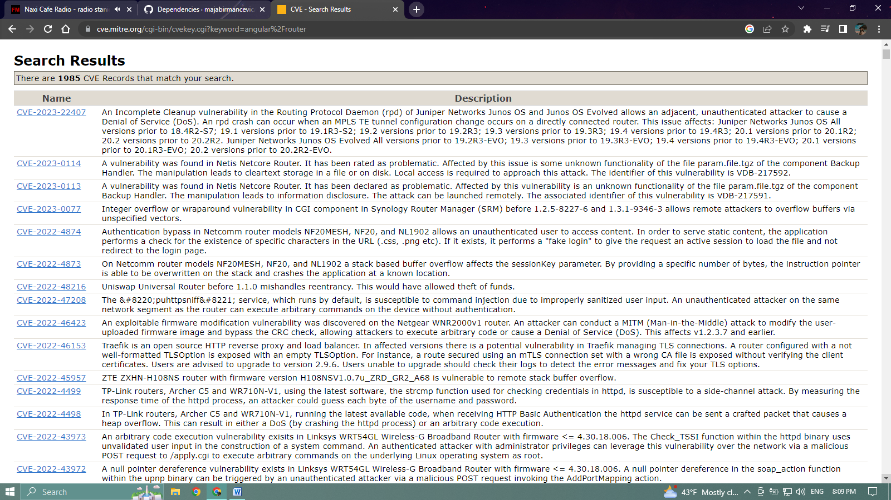

* **types/jasmine**

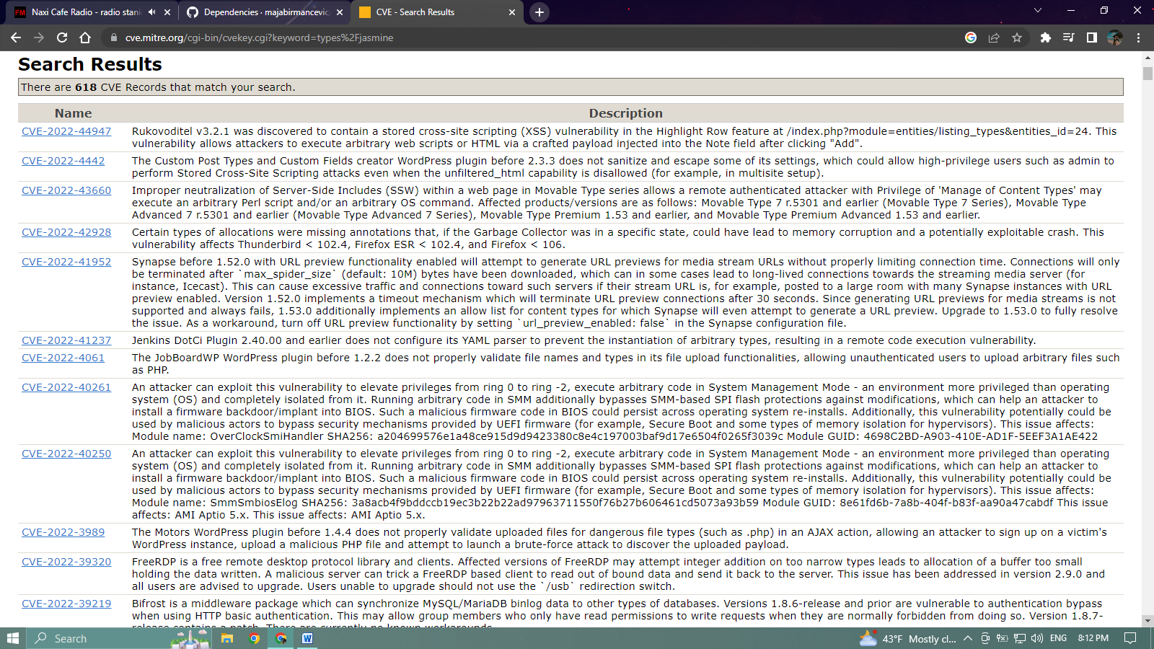**link:** [**https://cve.mitre.org/cgi-bin/cvekey.cgi?keyword=types%2Fjasmine**](https://cve.mitre.org/cgi-bin/cvekey.cgi?keyword=types%2Fjasmine)

* **bootstrap**

**link:** [**https://cve.mitre.org/cgi-bin/cvekey.cgi?keyword=bootstrap**](https://cve.mitre.org/cgi-bin/cvekey.cgi?keyword=bootstrap)

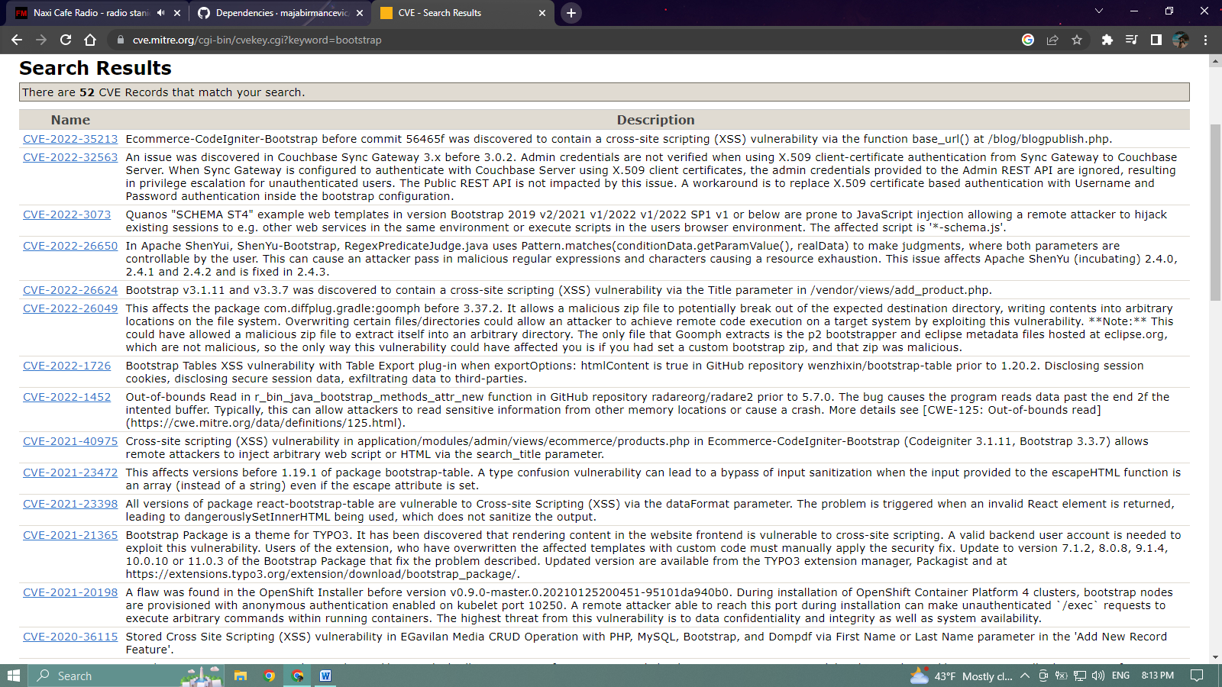

* **karma-runner / karma**

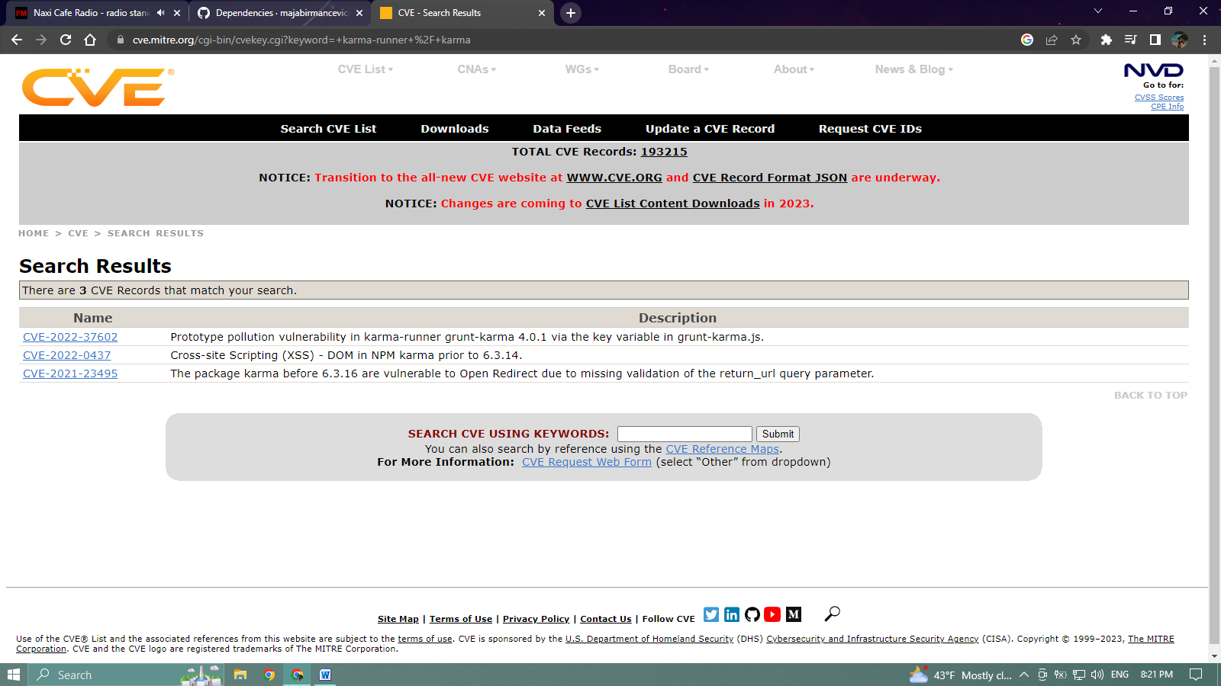

* **ng-recaptcha**

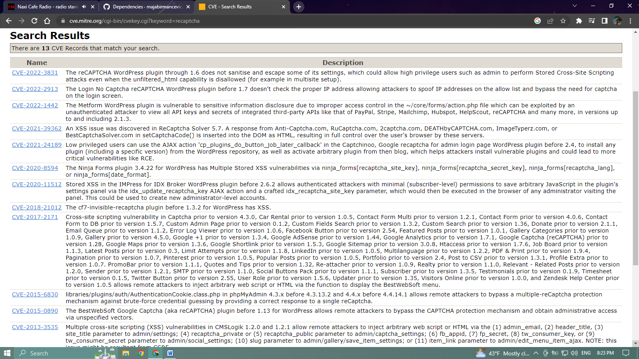

* **ngx-toastr**

